Appendix H

Traffic Counts

(Based on one week of placement at listed location, unless otherwise noted)

CRAWFORD COUNTY

Cuba - Orchard Street (October 13, 2019)

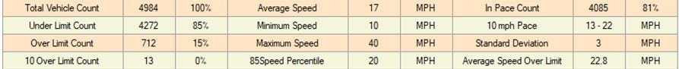

DENT COUNTY

Dent County – County Road 6490 (June 29, 2017)

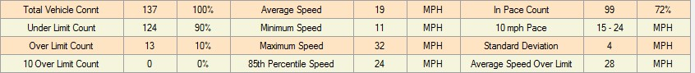

Dent County – Hwy H & County Road 2400 (November 1, 2017)

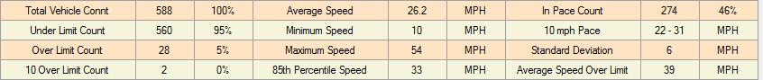

GASCONADE COUNTY

Bland – Highway 28 (June 25, 2020)

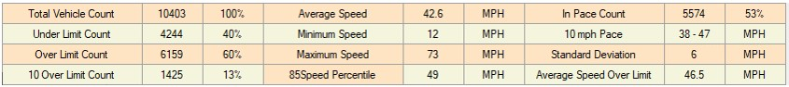

Bland – Highway 28 (June 29, 2020)

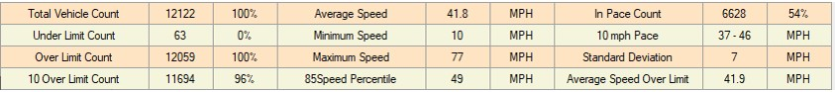

Bland – Highway 28 (July 1, 2020)

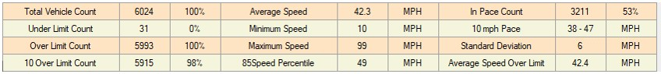

Bland – Highway 28 (July 16, 2020)

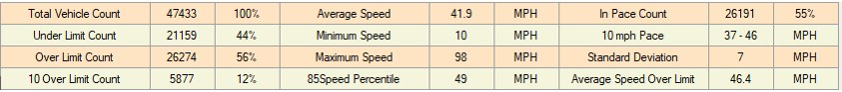

Bland – Highway 28 (July 21, 2020)

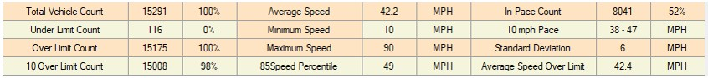

Bland – Highway 28 @ Pallet Lumber Exp. (August 3, 2020)

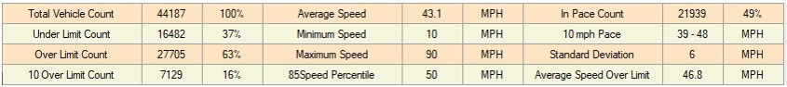

Bland – Highway 28 @ Pallet Lumber Exp. (August 12, 2020)

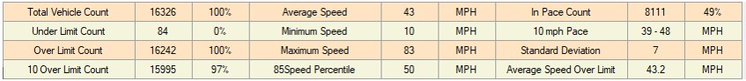

Bland – Highway 28 @ Pallet Lumber Exp. (August 17, 2020)

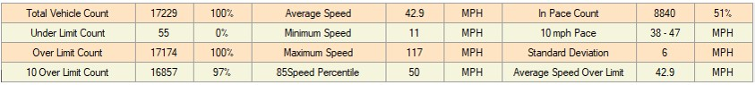

Bland – Highway 28 (February 1, 2023)

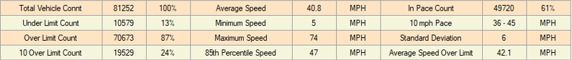

Gasconade County – 1975 Old Woolam Rd (May 3, 2023)

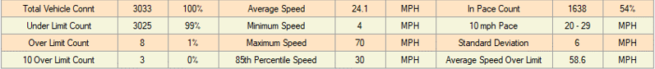

Hermann – Highway 19 (February 7, 2018)

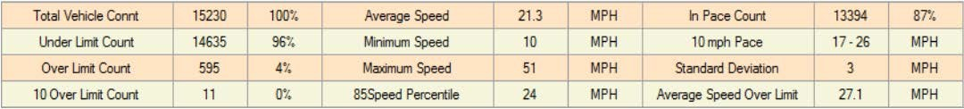

Hermann – Highway 19 (February 14, 2018)

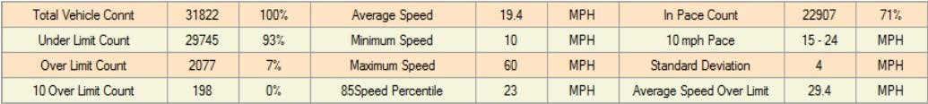

Hermann – Washington St. and Gellert St. (March 29, 2019 and April 5, 2019)

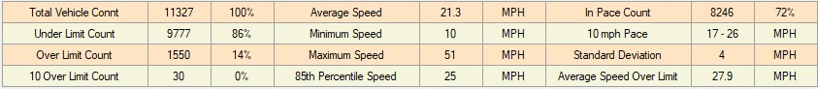

Owensville – Highway 19 (March 24, 2017)

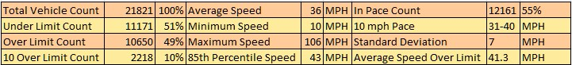

# Owensville – Highway 19 (March 31, 2017)

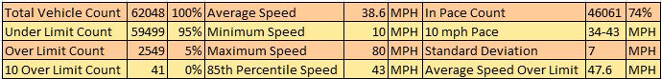

# Owensville – Highway 28 (June 5, 2019)

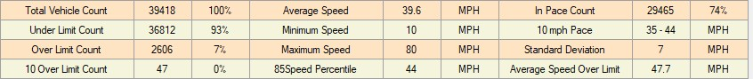

# Owensville – Highway 28 (June 7, 2019)

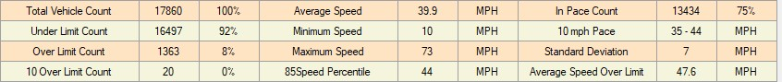

Owensville – Highway 19 North (June 14, 2019)

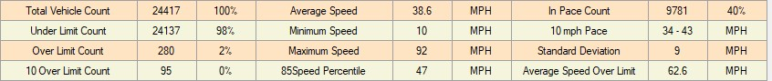

# Rosebud – Highway 50 (July 6, 2017)

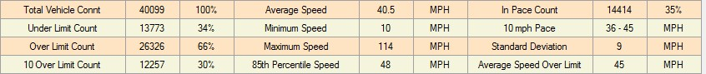

# Rosebud – Highway T (July 13, 2017)

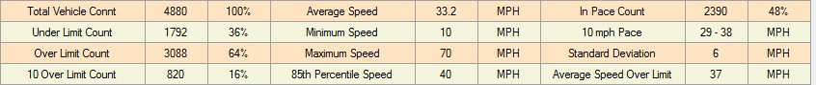

# Rosebud – Highway 50 (October 9, 2018)

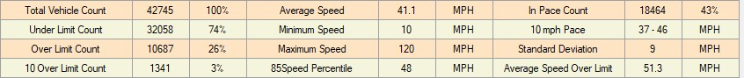

Rosebud – Highway 50 (October 17, 2018)

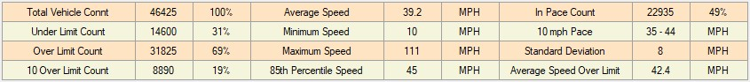

Rosebud – Highway 50 East Side (June 21, 2019)

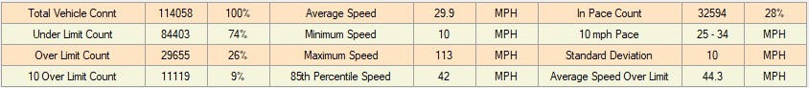

Rosebud – Highway 50 West Side (October 7, 2019)

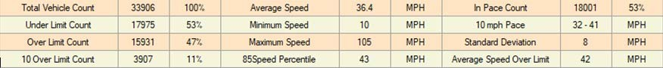

Rosebud – 213 W Rosebud Ave (October 25, 2022)



Rosebud – E Red Oak Ave and 3rd St (November 30, 2022)

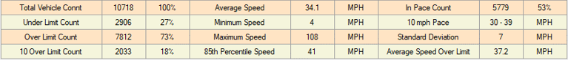

Maries County

Belle – 433 W. 3rd Street, Belle, MO (January 22, 2023)

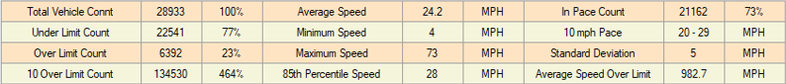

Belle – 224 E 1st Street, Belle, MO

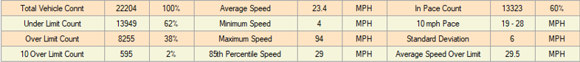

OSAGE COUNTY

Argyle – HWY T (March 8, 2023)

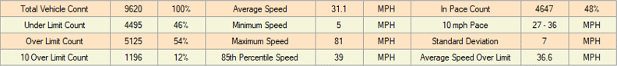

Argyle – HWY T (April 5, 2023)

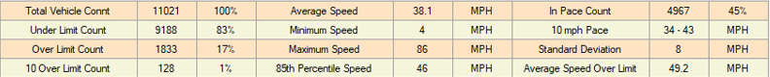

Meta – E 6th St and N Rose (July 29, 2022)

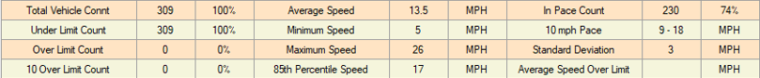

Osage County – 1780 Hwy 50 E (August 31, 2022)

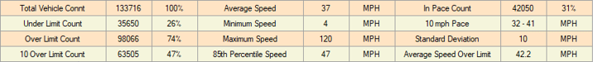

Osage County – 2390 County Road 508 (October 10, 2022)



Osage County – 700 County Road 365 (November 2, 2022)

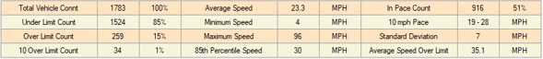

Osage County – 365 County Road 303 (November 2, 2022)

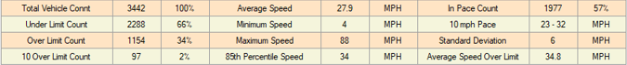

PHELPS COUNTY

Doolittle – Highway T (August 19, 2020)

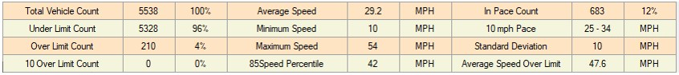

St. James – Highway 68 & Scioto Street (February 24, 2017)

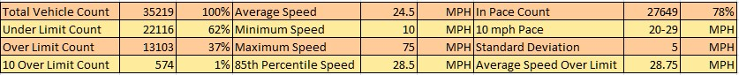

St. James – Meramec Street (June 16, 2017)

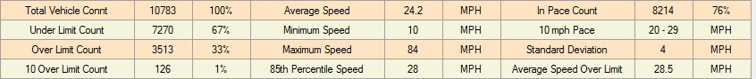

St. James – Emory Street (April 7, 2019)

St. James – Emory Street (April 12, 2019)

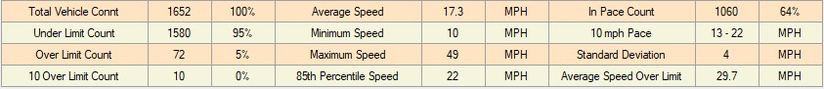

# St. James – Highway 68 (April 22, 2019)

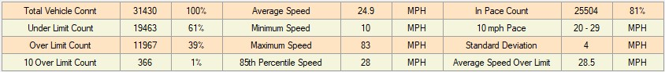

# St. James – Highway 68 (Easter Weekend April 24, 2019)

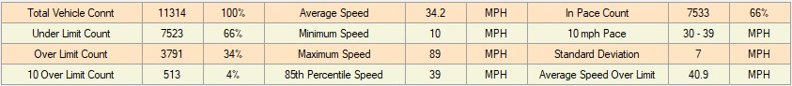

# St. James – Matlock Drive (May 3, 2019)

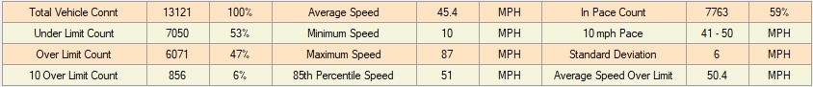

# St. James – Matlock Drive (May 10, 2019)

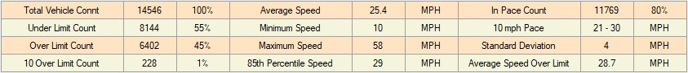

St. James – Highway 68 & 300 South Jefferson facing South (July 16, 2019)

St. Jame

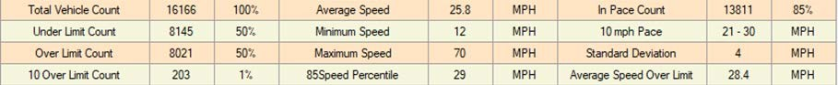

St. James – Highway 68 & 300 South Jefferson facing South (July 19, 2019)

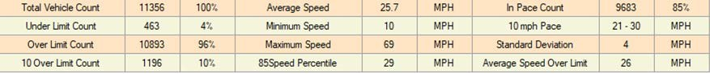

St. James – Highway 68 & 300 South Jefferson facing South (July 26, 2019)

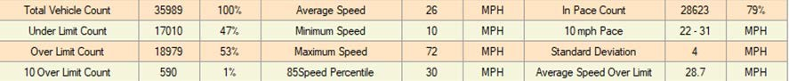

St. James – Highway 68 & 300 South Jefferson facing South (July 29, 2019)

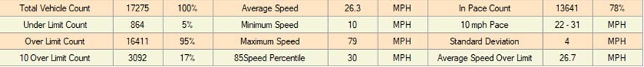

St. James – Highway 68 & 300 South Jefferson facing South (August 2, 2019)

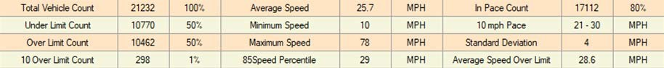

St. James – Highway 68 & 300 South Jefferson facing South (August 9, 2019)

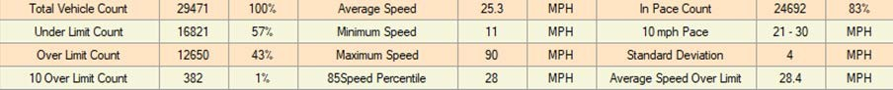

St. James – Walters Avenue (October 14, 2019)

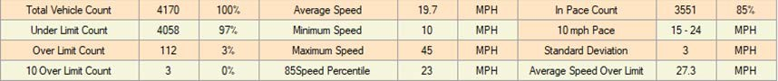

St. James – Walters Avenue (October 21, 2019)

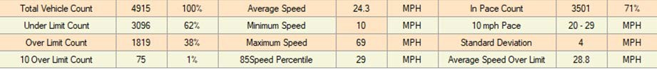

St. James – Highway 68 (May 24, 2021)

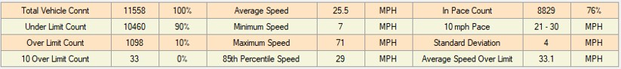

St. James – E. Charles St. (May 24, 2021)

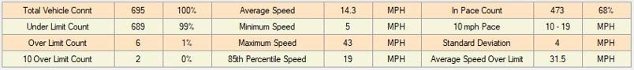

# PULASKI COUNTY

Pulaski County – 16939 Resort Road (July 6, 2022)

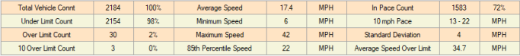

Pulaski County – 16742 Riverside Rd (July 20,2022)

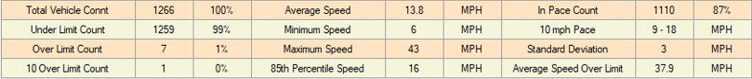

Pulaski County – 21090 Teardrop Road (December 28, 2022)

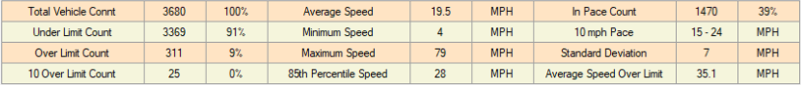

St. Robert – St. Robert Boulevard (May 16, 2017)

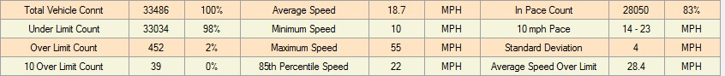

St. Robert – St. Robert Boulevard (May 23, 2017)

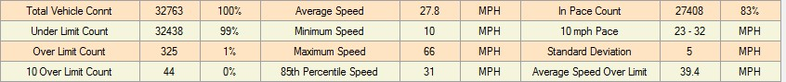

# WASHINGTON COUNTY Caledonia –Highway 21 (October 18, 2017)

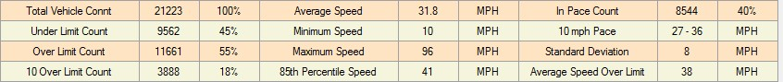

Potosi – Highway 8 at Rt O & U (August 19, 2020 through March 2021 – Not working)