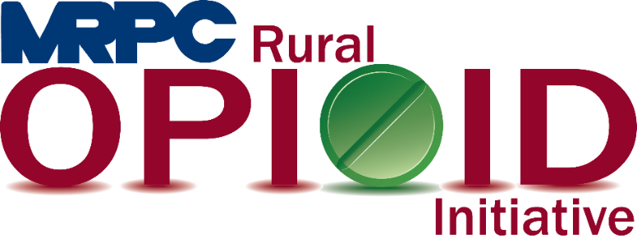

Meramec Region Recovery Alliance Consortium Meeting

February 2, 2024, 12:00 p.m.

Zoom Meeting

<https://us02web.zoom.us/j/86139441719?pwd=cnY5K3pQakNLbVNPNUVsb3duK0FOZz09>

Meeting ID: 861 3944 1719

Passcode: 044821

1. **Call to Order and Introductions:** MRPC Staff, Samantha Sherman
2. **Staff Report:** MRPC staff will report on grant updates.
   1. Seeking Safety
      1. Ann Feeler will give an update on the current Seeking Safety programs being taught.
   2. Drop Boxes
      1. The consortium will discuss relocating the drop box that is currently at Vandivort’s in Salem and discuss the drop box in Gasconade County.
   3. Narcan Training
      1. Samantha is still trying to teach Narcan administration in each of our counties.
3. **SWOT:** MRPC, Anne Freand
   1. The consortium will perform a quick Strengths, Weaknesses, Opportunities, and Threats and prioritize those to begin the framework for future funding searches and the application process.
4. **Program Updates:** Members will update the group on their current efforts for the consortium and the progress they have made. Members will also have the opportunity to discuss any upcoming events or opioid related programs they are working on.
5. **Adjourn:** MRPC Staff, Samantha Sherman