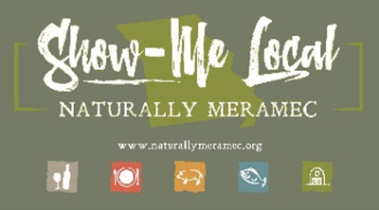2791

Naturally Meramec Consortium Regional Meeting

Tuesday, July 25, 2023, 4:00 p.m.

Cuba Visitor Center

71 State Highway P, Cuba, Missouri 65453

**Agenda**

1. **Call to Order and Introductions:** Mark A. Perkins, Senior Community Development Specialist, Meramec Regional Planning Commission will introduce Kim Roedemeier of the Cuba Visitor Center to provide everyone with a tour and to talk about the facility and what they are doing for tourism in Cuba, Missouri.
2. **Staff Report:** Meramec Regional Planning Commission Staff will report on Naturally Meramec Consortium activities through Tuesday, July 25, 2023.
   1. Naturally Meramec Consortium Facebook Page.
   2. Naturally Meramec Consortium Website.
   3. Naturally Meramec Consortium Events.
3. **Missouri’s Meramec Region Food Hub:** MRPC Staff will discuss the Missouri’s Meramec Region Food Hub and deliverables identified in the Delta Regional Authority grant. The Naturally Meramec Consortium will then discuss the best way to implement a food hub in the Meramec Region.
4. **Announcements:** Members will have an opportunity to announce special events in their areas.
5. **Next Meeting:** Tuesday, August 29, 2023, at 4:00 p.m. at Meramec Regional Planning Commission located at 4 Industrial Drive, St. James, Missouri.
6. **Adjournment:** Mark A. Perkins, Senior Community Development Specialist, Meramec Regional Planning Commission.
7. **Networking:** Members will have an opportunity to network.