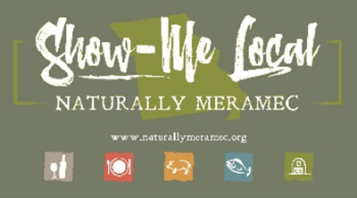2791

Naturally Meramec Consortium Regional Meeting

Tuesday, February 28, 2023, 4:00 p.m.

Meramec Regional Planning Commission

4 Industrial Drive, St. James, Missouri 65559

**OR**

Via Zoom Conference Video/Call

Join Zoom Meeting

https://us02web.zoom.us/j/87675395185?pwd=MnkzdDRpNjlYVUFYSmlNMViUNHZTQT09

Meeting ID: 876 7539 5185

Passcode: 033910

Dial by your location.

+1 312 626 6799 US (Chicago)

**Agenda**

1. **Call to Order and Introductions:** Mark A. Perkins, Senior Community Development Specialist, Meramec Regional Planning Commission.
2. **Staff Report:** Meramec Regional Planning Commission Staff will report on Naturally Meramec Consortium activities through Tuesday, February 28, 2023.
   1. Naturally Meramec Consortium Facebook Page.
   2. Naturally Meramec Consortium Website.
3. **Strategic Plan:** MRPC Staff will discuss the 2023 Strategic Plan for Missouri’s Meramec Region. The Naturally Meramec Consortium will then be asked to offer comments or suggestions on the final draft of the plan.
4. **New Delta Regional Authority (DRA) Grant:** MRPC Staff will discuss the DRA Grant in detail.
5. **Announcements:** Members will have an opportunity to announce special events in their areas.
6. **Next Meeting:** Tuesday, March 28, 2023, at 4:00 p.m.
7. **Networking:** Members will have an opportunity to network.
8. **Adjournment:** Mark A. Perkins, Senior Community Development Specialist, Meramec Regional Planning Commission.