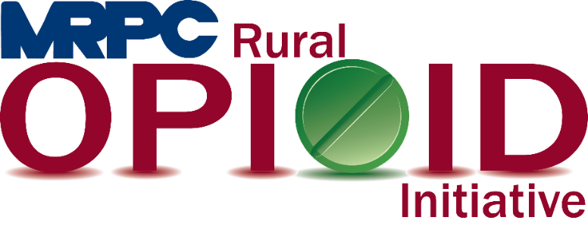

Meramec Region Recovery Alliance Consortium Meeting

November 9, 2022, 2:00 p.m.

Zoom Meeting

<https://us02web.zoom.us/j/81678498012?pwd=d0M0RDE5SlZMd1hmVks2T0RMVjZlUT09>

Meeting ID: 816 7849 8012

Passcode: 536236

1. **Call to Order and Introductions:** MRPC Staff, Samantha Sherman
2. **Staff Report:** MRPC staff will report on grant updates
   1. Seeking Safety
      1. Rebecca Losing and Ann Feeler will give the group an update on the Seeking Safety program’s recent classes.
   2. Data Tracking Document
      1. Ann Feeler will review the new data collection worksheet with the group to begin using for our data reporting to HRSA.
3. **Program Updates:** Members will update the group on their current efforts for the consortium and the progress they have made. Members will also have the opportunity to discuss any upcoming events or opioid related programs they are working on.
4. **Adjourn:** MRPC Staff, Samantha Sherman