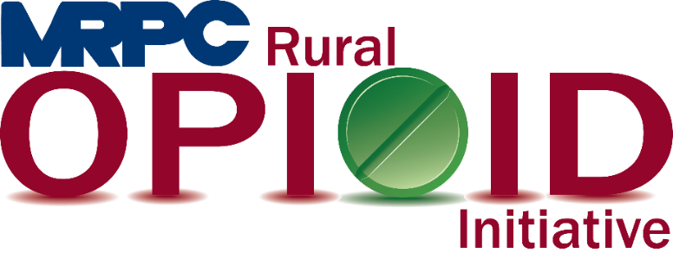

Meramec Region Recovery Alliance Consortium Meeting

July 29, 2022, 2:00 p.m.

Zoom Meeting

<https://us02web.zoom.us/j/84821616732?pwd=QStoQjJXQVFXUXBGRUx3MDBpWTlKUT09>

Meeting ID: 848 2161 6732

Passcode: 705646

1. **Call to Order and Introductions:** MRPC Staff, Samantha Sherman
2. **Staff Report:** MRPC staff will report on grant updates
   1. Seeking Safety
      1. Rebecca Losing will give the group an update on the Seeking Safety program’s recent classes.
   2. Awareness Events
      1. Ann Feeler will prove an update to the group on the upcoming Awareness Walks and Overdose Awareness Day on August 31, 2022
3. **Reporting Requirements:** MRPC Staff
   1. PIMS Report
      1. Due September 30 to HRSA (March 1 – August 31). Please submit no later than September 15 for staff to compile results and submit on time.
   2. Performance Report
      1. Due September 30 to HRSA (Year 1). Please submit a year end report like you have in the past no later than September 15 for staff to compile results and submit on time.
   3. Sustainability Plan
      1. Consortium will review the document that Samantha updated since the previous meeting. Samantha will make recommended changes and then submit to HRSA staff.
4. **Program Updates:** Members will update the group on their current efforts for the consortium and the progress they have made. Members will also have the opportunity to discuss any upcoming events or opioid related programs they are working on.
5. **Adjourn:** MRPC Staff, Samantha Sherman