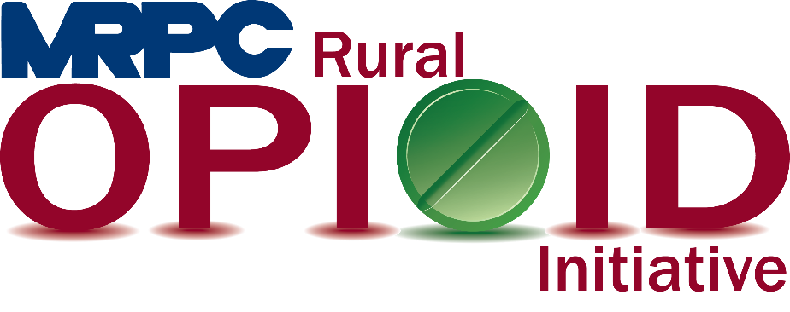

Meramec Rural Opioid Program Consortium Meeting

June 28, 2022, 10:00 a.m.

Meramec Regional Planning Commission – 4 Industrial Drive, St. James, Missouri

Zoom Meeting

**MEMBERS PRESENT:** Sean Siebert; Invent Yourself, LLC, Kelly Brueggen; Washington County Memorial Hospital, Rebecca Gann; Central Ozarks Medical Center, Deborah Decker; Pulaski County Health Department, Felisha Richards; Four Rivers Community Health Center

**STAFF PRESENT:** Samantha Sherman, Rebecca Losing, Anne Freand

**Minutes**

1. **Call to Order and Introductions:** Samantha Sherman called the meeting to order at 10:05 a.m. Introductions were made between all meeting attendees.
2. **Staff Report:** Samantha began the staff report by giving an update on the status of Narcan purchasing for the health departments. At this point, three of the six departments have received their orders, and the remaining departments are finalizing their accounts to place their orders. Samantha encouraged them to continue to work on this as she would like to have this completed before she goes on Maternity Leave.

Samantha then updated the group on the status of the Narcan trainings in our schools. She provided information on the “NarKits” that were purchased as a leave behind item to be placed in the AEDs in the schools already. Samantha has completed her “Train the Trainer” program and will begin school trainings once she returns from leave.

1. **Re-Entry Checklist:** Rebecca presented the re-entry to the consortium. She also discussed the plan of action on how we plan to distribute the checklist. The goal is to discuss the checklist while teaching Seeking Safety and then when the program is complete, leave enough with each of the jails to provide one to each person as they are released. Felisha suggested that on the chapter title pages we also include a contact person from one of our local social service organizations that could help walk someone through completing that specific chapter. This information will be added as the group agreed it was a very beneficial option for those who are using the checklist.
2. **Reporting Requirements:** Samantha reminded everyone that the PIMS report (March 1 to August 31, 2022) and Performance Report (September 1, 2021 to August 31, 2022) will be due to HRSA on September 30. Please submit this information to Anne NO LATER THAN SEPTEMBER 15, 2022, to allow her to compile the information and submit on time.

The final plan discussed was the Sustainability Plan. The group spent time determining both internal and external assets and challenges to the consortium. Samantha will take those responses and create action items for the report. This document will be brought to the group at the July consortium meeting to review the action items and make any necessary changes before submitting to HRSA.

1. **Program Updates:** Consortium members were able to update the group on what was going on in their counites or cities and what they were up to as an organization.

Invent Yourself, LLC: Dr. Sean updated the group that he has completed the Rehabilitation Through Innovation program in both Pulaski and Crawford County and is currently working the Osage County Jail. He also spoke about the upcoming Community Conversation to be held on July 14th at 12:00 p.m. The meeting is open to everyone, but specific invites were sent to jail administrators, CIT members, and MAT providers in our region.

Washington County Memorial Hospital: Kelly Brueggen indicated that she has a good relationship with the Washington County Jail and may be able to help us make contact and work to begin two programs. She discussed that she is working with the local SB-40 board to make communication around healthcare more “neuro-diverse” so everyone understands what is written. She suggested potentially partnering with other counties to mass produce the information to be able to mass distribute to more residents.

Central Ozark Medical Center: Rebecca Gann updated the group that MAT services in Maries County have begun in the Laurie Clinic.

Pulaski County Health Department: Deborah Decker updated the group that back-to-school shots are beginning in Crocker for children and adults and will include COVID-19 vaccinations. They are in the process of moving their office to Waynesville near Price Chopper. Deborah let the consortium know that WIC has recently changed their formula requirements and clients will be able to order specialty formula through health department’s office. She also indicated that they would have opioid awareness activities coming up in the fall. They also have a large supply of Narcan available for first responders and the community.

Four Rivers Community Health Center: Felisha updated the group that the community has seen a large increase in overdoses. These overdoses appear to have been caused by mixing benzos and fentanyl together which is taking multiple doses of Narcan to reverse the effects.

Felisha also updated the group about the new and exciting things happening at Four Rivers Community Health Center. They just completed the Ribbon Cutting at the new St. Robert office and the ribbon cutting at the addition in Rolla will be August 11, 2022, at 9:00 a.m. The clinic is being dedicated to Dr. Bonnie Rainey. Back to School clinics will be held August 19 and August 22. The diaper bank is officially open and running. As of now, it is only being offered to current patients, but they are hoping to expand that service to the community in the future. The service currently supplies diapers, but they are looking to add more feminine care products in the future.

1. **Adjourn:** Meeting was adjourned at 11:47 a.m.