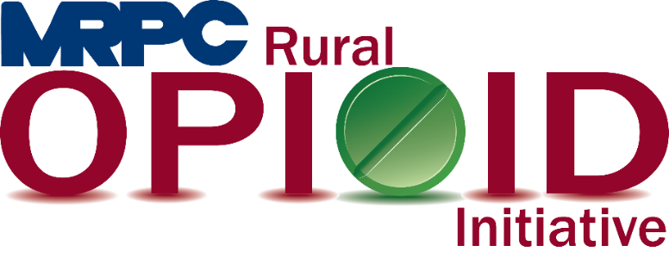

Rural Opioid Initiative Quarterly Consortium Meeting.

June 30, 2021, 1:00 p.m.

Zoom Meeting

<https://us02web.zoom.us/j/87340545705?pwd=UXhZdmZVZlZDWGJYc1lSQ0k5OGhYQT09>

Meeting ID: 873 4054 5705

Passcode: **798543**

1. **Call to Order and Introductions:** MRPC Staff, Samantha Maddison
2. **Approval of February 25, 2021, meeting minutes:** MRPC Staff, Samantha Maddison
3. **Staff Report:** MRPC staff will report on grant updates.
   1. Upcoming virtual workshop
4. **Seeking Safety update:** MRPC Staff, Christa Harmon
   1. Christa will give an update on the upcoming Seeking Safety program in Maries County.
5. **Program Updates:** Members will update the group on their current efforts for the consortium and the progress they have made. Members will also discuss any upcoming events or opioid related programs they are working on.
6. **Next Meeting:** MRPC Staff, Samantha Maddison
   1. September 29, 2021 @ 1:00 p.m.
7. **Adjourn:** MRPC Staff, Samantha Maddison