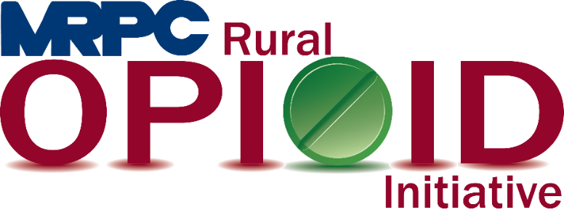

Meramec Region Recovery Alliance Consortium Meeting

June 28, 2022, 10:00 a.m.

Zoom Meeting

<https://us02web.zoom.us/j/85034087925?pwd=ajHbO3Jxig4C9OgCQL8rs43K5f0GUv.1>

Meeting ID: 850 3408 7925

Passcode: 320456

1. **Call to Order and Introductions:** MRPC Staff, Samantha Sherman
2. **Staff Report:** MRPC staff will report on grant updates
   1. Narcan Purchasing
      1. Crawford, Pulaski, and Washington complete
      2. Still working with other counties. Everyone should have received an email on 6/22/22 and then a phone call was made to many of you as well. MRPC staff would like to wrap up the first round of purchasing by 6/30/22.
   2. Narcan training in schools
      1. Purchasing “NarKits” as a leave behind for each of the AED’s at the school I am providing training and then reaching out to schools who expressed interest in Narcan but I cannot complete training this semester. I will be stopping by the Health Departments to grab a Narcan for each kit when I go to trainings.
3. **Re-Entry Checklist:** MRPC Staff
   1. MRPC staff will present the re-entry checklist to the consortium. Staff will provide both the actual document and then the plan for disseminating the document in our counties.
4. **Reporting Requirements:** MRPC Staff
   1. PIMS Report
      1. Due September 30 to HRSA (March 1 – August 31). Please submit no later than September 15 for staff to compile results and submit on time.
   2. Performance Report
      1. Due September 30 to HRSA (Year 1). Please submit a year end report like you have in the past no later than September 15 for staff to compile results and submit on time.
   3. Sustainability Plan
      1. Due to HRSA by end of July. Please note the attachment sent with the meeting invite on 6/22/22. Consortium will work on this document today. Staff will compile results and send back out for edits and suggestions.
5. **Program Updates:** Members will update the group on their current efforts for the consortium and the progress they have made. Members will also have the opportunity to discuss any upcoming events or opioid related programs they are working on.
6. **Adjourn:** MRPC Staff, Samantha Sherman