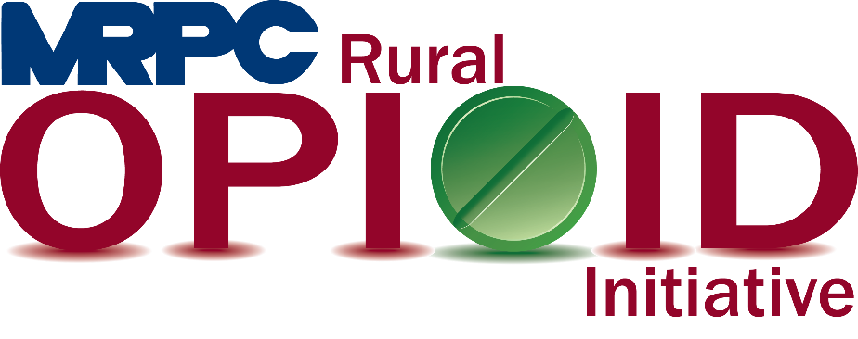

Meramec Rural Opioid Program Consortium Meeting

February 25, 2021 10:00 a.m.

Meramec Regional Planning Commission – 40 Industrial Drive, St. James, MO

Zoom Meeting

**MEMBERS PRESENT:** Greg Roeback, Jamie Myers, Sean Siebert, Felisha Richards, Linda Kozlowski

**STAFF PRESENT:** Samantha Maddison, Anne Freand, Rebecca Losing, Christa Harmon

**Minutes**

1. **Call to Order and Introductions:** Samantha Maddison called the meeting to order at 10:05 a.m. Introductions were not included as all attendees were familiar with each other.
2. **Ice Breaker:** Rebecca Losing completed an ice breaker questionnaire with the group to help keep attendees engaged in the meeting.
3. **Approval of December 3, 2020 meeting minutes:** Samantha Maddison presented the December 3, 2020 meeting minutes to the consortium for approval. Felisha Richards moved to approve the minutes and Greg Roeback seconded. Motion approved.
4. **Staff Report:** Samantha updated the consortium about the upcoming grant that MRPC is applying for. The RCORP Implementation II grant is for up to $1 million over three years and, if awarded, will take affect in September 2021. During this update, Felisha let the consortium know that Your Community Health Center was also applying for the RCORP Implementation II grant for Maries and Phelps Counties. MRPC will reach out to YCHC to discuss intended work plans.
5. **Seeking Safety Update:** Christa Harmon updated the group on the status of the Seeking Safety program she is completing in the Maries County Jail. Maries County Seeking Safety, Session 2 wrapped up on February 17, 2021. In total there were 48 participants, 16 female and 32 males, of which one male completed all 25 lessons and one other male completed 20 lessons.
6. **Program Updates:** Members updated the group on their current efforts for the consortium and the progress they have made. Members also had the opportunity to discuss any upcoming events or opioid related programs they are working on. Members were encouraged to send any updates via email to be sent out to the entire consortium following this meeting.
   1. Your Community Health Center: Felisha again reminded the consortium know that YCHC is applying for the RCORP Implementation II grant. She also informed the group that YCHC is longer doing drive through testing for COVID-19 because the number of cases in the county have decreased to a much lower amount. They are, however, beginning to provide vaccines to their patients. At this point, all of the providers at YCHC are MAT waivered and the clinic has over 250 MAT patients. The mobile clinic is doing well but has been closed recently because of the weather. Felisha is hoping to be able to provide some information about offering prenatal care to patients soon.
   2. Prevention Consultants: Jamie reported to the group that Prevention Consultants is currently in Newburg Middle School, Salem High School, all Rolla Middle School (4, 5, 6), Rolla High School, Edgar Springs, and the Rolla High School Health Class. They are still having trouble getting ahold of Belle. Samantha gave a couple recommendations of who to reach out to in Belle to see if that would work.
   3. Invent Yourself, LLC: Sean updated the group that he has completed the Rehabilitation Through Innovation program in the Maries County Jail, Crawford County Celebrate Recovery, and the Mission in Phelps County. He is set to enter the Crawford County Jail the second week of March. The program will be focused only on the women’s jail. Sean said this may change depending on staffing at the jail.
   4. Great Mines Health Center: Greg updated the group about their current MAT groups that are taking place and mentioned that the groups are able to meet face to face again. The health center has been able to begin working with the 24th judicial circuit to help those who need to enter treatment for substance use disorder. In about four months Great Mines will have six providers MAT certified. Greg also informed the consortium that they are opening up a new clinic in Farmington, which is their fifth school district to have a satellite clinic.
   5. Phelps/Maries County Health Department: Linda reported that they have been strictly focused on COVID and do not have a lot to report to the group. It does appear, however, that Narcan use in the county has seen a major increase since the last meeting. The county expects this to happen again as the stimulus checks are released.
7. **Next Meetings:** Consortium will be sent a survey to schedule meeting for next quarter.
8. **Adjourn:** Sean Siebert motioned to adjourn the meeting; Greg Roeback seconded. Motion passed. Meeting was adjourned at 11:23 a.m.