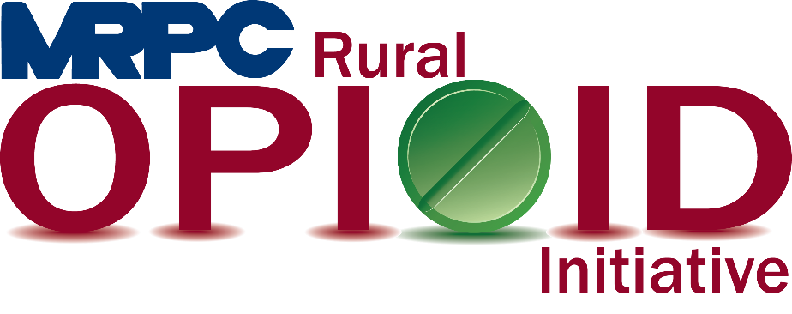

Meramec Rural Opioid Program Consortium Meeting

January 26, 2022, 2:00 p.m.

Meramec Regional Planning Commission – 4 Industrial Drive, St. James, Missouri

Zoom Meeting

**MEMBERS PRESENT:** Sean Siebert; Invent Yourself, LLC, Tim Long; Celebrate Recovery, Jamie Myers; Prevention Consultants of Missouri, Mason Griffith, Rosebud Police Department

**STAFF PRESENT:** Samantha Sherman, Rebecca Losing

**Minutes**

1. **Call to Order and Introductions:** Samantha Maddison called the meeting to order at 2:04 p.m. Introductions were made between all meeting attendees.
2. **Staff Report:** Samantha began the staff report by discussing the unused medication drop boxes. Samantha informed the consortium that all drop boxes has been purchased and decisions needed to be made about where they would be placed. Members on the call discussed potential locations for the drop boxes as follows:

* Gasconade County 911 office in Rosebud: Rosebud Police Chief, Mason Griffith, would love to house the drop box. Due to limited hours that the police station is open, he suggested that maybe the box be located at the 911 office as they are open and staffed 24/7. Mason will reach out to the 911 office and report back to MRPC to let them know if the office is interested.
* Potosi Police Department: Jamie Myers indicated that the Potosi Police Department had reached out to them inquiring about how to go about getting a drop box installed in their office. Jamie’s staff will reach out to the police department and see if they are still interested and will let Samantha know how to proceed.
* Others suggested that maybe the Hermann Senior Center house a drop box. Samantha is going to reach out to the state to determine the requirements for housing a drop box along with who to contact for pick up of the unused medications that are collected.

Rebecca provided information about recovery groups in the region. She will be providing the list to the consortium in the coming weeks for their edits and additions. Rebecca also mentioned that the Opioid Affected Youth Initiative will be hosting an event for Black Balloon Day in some of our counties March 4-7. She will send more information as it is available.

Samantha then reported that she has met with Your Community Health Center and Washington County Memorial Hospital to discuss potential overlap in our services. We were able to discuss exactly what activities were being completed by both grants and how we will ensure that we do not provide those same services in their areas. Samantha is set to meet with Richland Medical Center in the coming weeks to have to same discussion. Samantha then asked the group if they had any additional individuals, they would be interested in adding to the commission. Samantha inquired about adding a workforce person to the list and suggested Sundi Jo Graham. Samantha will reach out to Sundi Jo to determine her interest. Another suggestion for the workforce representative was Chris Link from the Rolla Job Center. Dr. Sean suggested Samantha reach out to anyone on the clinical side of SUD at Your Community Health Center and determine their interest in our consortium as well.

1. **Reporting Requirements:** Samantha provided more information on the upcoming PIMS reporting that is due to HRSA March 31, 2022. Samantha will send out the reporting document in early February for the consortium members to begin gathering their data. Samantha would like all information submitted to her by March 15 so she has time to compile all data and reach out with any potential questions before the deadline.
2. **Program Updates:** Consortium members were able to update the group on what was going on in their counites or cities and what they were up to as an organization.

Rosebud Police: Mason invited all consortium members to attend the Gasconade County CIT meetings held in varying locations around the county on the first Thursday of the month at 1:00 p.m. If someone is interested in attending these meetings, please send Chief Griffith an email and he will add you to the invite list.

Invent Yourself, LLC: Sean informed the group that he would be starting the Rehabilitation Through Innovation program in Pulaski County in Early February. He is in the process of scheduling the day of the week and will let MRPC know as soon as that is determined. He indicated to the group that he had just completed the program in the Phelps County Jail with a group of 9 women for the previous HRSA grant as well. Sean also indicated that the individuals who helped with the Community Conversation in Crawford County are interested in hosting part two. Sean will reach out soon to begin planning the event.

Prevention Consultants of Missouri: Jamie Myers reported to the group that his staff are currently teaching Too Good for Drugs in the Cuba Middle School. They were in the Salem school district for approximately three weeks and were able to help them continue with the program through their Drug Free Communities grant. They are also in the St. James Middle School in all grades.

Celebrate Recovery of Gasconade County: Tim informed the consortium that he is currently preparing for three more graduates from the John 3:16 program in Arkansas and is helping them look for employment. He is also looking for ideas for housing ideas to purchase to continue working on his housing plan for individuals in recovery. He indicated that he has a few ideas, but he will have to wait and see what happens with these ideas.

1. **Adjourn:** Meeting was adjourned at 2:57 p.m.