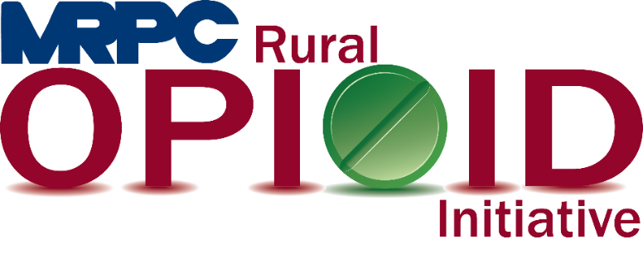

Meramec Region Recovery Alliance Consortium Meeting

January 19, 2022, 2:00 p.m.

Zoom Meeting

<https://us02web.zoom.us/j/88270428415?pwd=MHZuOVpkL2RLWlZocWFScU1TQlZqZz09>

Meeting ID: 882 7042 8415

Passcode: 233141

1. **Call to Order and Introductions:** MRPC Staff, Samantha Sherman
2. **Staff Report:** MRPC staff will report on grant updates
   1. Prescription Drop Boxes, Samantha Sherman
      1. Locations
      2. Contact person for each location
   2. Recovery Groups, Rebecca Losing
   3. Grant overlap meetings and discussions, Samantha Sherman
   4. Additional consortium members discussion, Samantha Sherman
3. **Reporting Requirements:** MRPC Staff
   1. PIMS Report Requirements
      1. Samantha will explain what is required from each consortium member to complete the PIMS reporting
4. **Program Updates:** Members will update the group on their current efforts for the consortium and the progress they have made. Members will also have the opportunity to discuss any upcoming events or opioid related programs they are working on.
5. **Adjourn:** MRPC Staff, Samantha Sherman