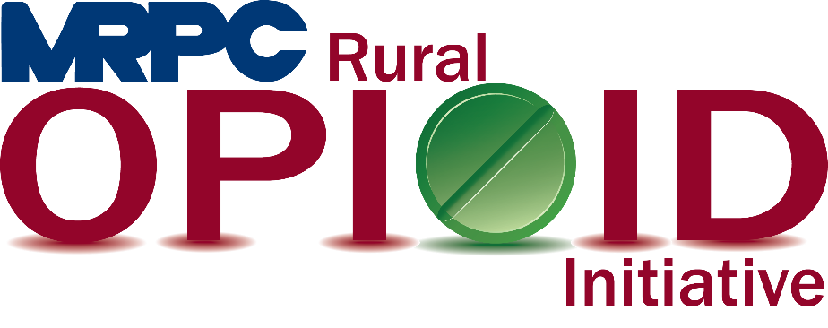

Meramec Rural Opioid Program Consortium Meeting

October 13, 2021, 2:00 p.m.

Meramec Regional Planning Commission – 4 Industrial Drive, St. James, Missouri

Zoom Meeting

**MEMBERS PRESENT:** Sean Siebert; Invent Yourself, LLC, Tim Long; Celebrate Recovery, Kelly Miller; Central Ozarks Medical Center, Jamie Myers; Prevention Consultants of Missouri

**STAFF PRESENT:** Samantha Maddison, Anne Freand, Christa Harmon, Rebecca Losing

**Minutes**

1. **Call to Order and Introductions:** Samantha Maddison called the meeting to order at 2:06 p.m. Introductions were made between all meeting attendees.
2. **Grant Introduction:** Samantha provided a basic overview of the upcoming activities for the grant. The consortium discussed the frequency of the meetings and decided they would like to keep the meetings to quarterly. A schedule and invite for each meeting will be sent out by Samantha soon. Samantha also discussed the process for invoicing MRPC for any contract services. She will provide a copy of the invoice used during the HRSA 1 grant to continue using during this grant as well. Samantha then went through the work plan with the consortium. Samantha highlighted some of the larger events that would be taking place over the next three years and included what would be expected of the consortium members. Deadlines for those participating in specific events will be sent out as the events approach.
3. **Reporting Requirements:** Samantha provided a copy of the Onboarding data requirements that is expected of each consortium member. Samantha will send a follow up email including exactly what each member needs to provide to MRPC. The document is due to the funder by the end of October, but Samantha will be out of the office beginning October 22 and will submit before she is out of office.
4. **Adjourn:** Meeting was adjourned at 2:39 p.m.