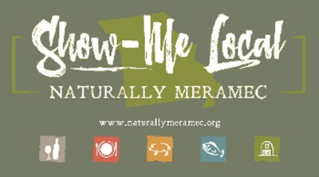2791

Naturally Meramec Consortium Regional Meeting

Tuesday, September 7, 2021, 6:00 p.m.

Meramec Regional Planning Commission

4 Industrial Drive, St. James, Missouri 65559

**OR**

Via Zoom Conference Video/Call

Join Zoom Meeting

https://us02web.zoom.us/j/85892382819?pwd=U2w3SGY5NVdickdVYjJBaWF1SEE4Zz09

Meeting ID: 858 9238 2819

Passcode: 218896

Dial by your location.

+1 312 626 6799 US (Chicago)

**Agenda**

1. **Call to Order and Introductions:** Mark A. Perkins, Senior Community Development Specialist, Meramec Regional Planning Commission.
2. **Staff Report:** Meramec Regional Planning Commission Staff will report on Naturally Meramec Consortium activities through Tuesday, August 31, 2021.
   1. Naturally Meramec Consortium Facebook Page.
   2. Naturally Meramec Consortium Website.
   3. Saturday, September 25, 2021, Naturally Meramec Consortium Taste of Crawford County.
   4. Saturday, October 16, 2021, Naturally Meramec Consortium Taste of Osage County.
3. **Naturally Meramec Consortium Strategic Planning Discussion:** Staff will present the draft plan for review by the consortium. The group will have time to discuss any proposed changes that need to be made to the final planning document.
4. **Announcements:** Members will have an opportunity to announce special events in their areas.
5. **Next Meeting:** Tuesday, September 28, 2021, at 6:00 p.m.
6. **Networking:** Members will have an opportunity to network.
7. **Adjournment:** Mark A. Perkins, Senior Community Development Specialist, Meramec Regional Planning Commission.