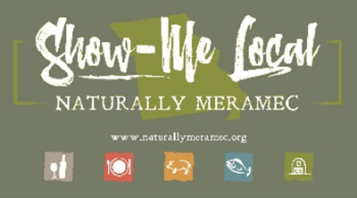2791

Naturally Meramec Consortium Regional Meeting

Tuesday, July 27, 2021, 6:00 p.m.

Meramec Regional Planning Commission, 4 Industrial Drive, St. James, Missouri

**OR**

Via Zoom Conference Video/Call

Join Zoom Meeting

https://us02web.zoom.us/j/89180237624?pwd=VVZDNWROdE9FdnllU05YRkxrcFRVdz09

Meeting ID: 891 8023 7624

Passcode: 090109

+19292056099,89180237624#, *090109# US (New York)

+13126266799, 8918023762#, *090109# US (Chicago)

Dial by your location.

+1 312 626 6799 US (Chicago)

Meeting ID: 891 8023 7624

Passcode: 090109

**Agenda**

1. **Call to Order and Introductions:** Mark A. Perkins, Senior Community Development Specialist, Meramec Regional Planning Commission.
2. **Staff Report:** Meramec Regional Planning Commission Staff will report on Naturally Meramec Consortium activities through Tuesday, July 27, 2021.
   1. Naturally Meramec Consortium Facebook Page.
   2. Naturally Meramec Consortium Website.
   3. Naturally Meramec Consortium Osage County Lunch and Learn.
   4. 2021 Missouri Agritourism Conference
   5. Monday, August 30, 2021, Naturally Meramec Consortium Speed-Date Event.
   6. Saturday, September 25, 2021, Naturally Meramec Consortium Taste of Crawford County
   7. Saturday, October 16, 2021, Naturally Meramec Consortium Taste of Osage County
3. **Naturally Meramec Consortium Strategic Planning Discussion:** The Meramec Regional Planning Commission Staff and the Naturally Meramec Consortium will discuss strategic planning for the Naturally Meramec Consortium in the Meramec Region.
   1. Review items discussed at the Tuesday, April 27, 2021, Naturally Meramec Consortium Regional Meeting and results of Tuesday, April 27, 2021, Naturally Meramec Consortium Regional Meeting Planning Survey
   2. Discussion of specific projects for the Naturally Meramec Consortium to pursue in the future
4. **Announcements:** Members will have an opportunity to announce special events in their areas.
5. **Next Meeting:** Tuesday, August 31, 2021, at 6:00 p.m. The Meramec Regional Planning Commission Staff and the Naturally Meramec Consortium will continue to work on the Naturally Meramec Consortium by prioritizing the results of the strategic planning from today’s Naturally Meramec Consortium Regional Meeting.
6. **Networking:** Members will have an opportunity to network.
7. **Adjournment:** Mark A. Perkins, Senior Community Development Specialist, Meramec Regional Planning Commission.