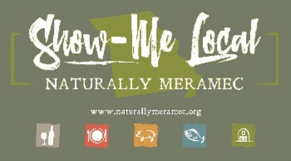

Naturally Meramec Consortium

Regional Zoom Meeting

April 30, 2020

Meramec Regional Planning Commission, 4 Industrial Drive, St. James, MO

6:00 p.m.

1. **Call to Order and Introductions:** Mark A. Perkins
2. **Approval of Minutes from the Monday, April 20, 2020 meeting:** Mark A. Perkins
3. **Staff Report:** Meramec Regional Planning Commission (MRPC) Staff will report on Naturally Meramec Consortium (NMC) activities through April 30, 2020.
4. **Presentation:** Christi Miller, Program Manager, Missouri Department of Agriculture will present on Missouri Grown. Missouri Grown is a program of the Missouri Department of Agriculture.
5. **Announcements:** Members will have an opportunity to announce special events in their areas.
6. **Next Meeting:** Thursday, May 28, 2020 at 6:00 p.m.
7. **Networking:** Members will have an opportunity to network.
8. **Adjournment:** Mark A. Perkins