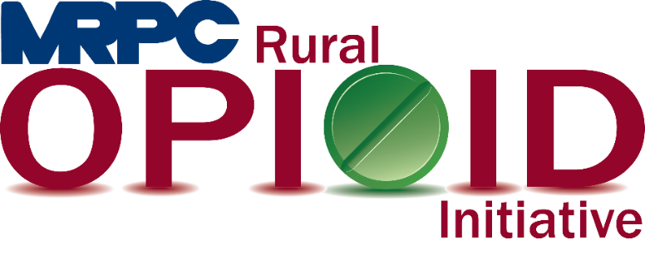

Rural Opioid Initiative Quarterly Consortium Meeting.

February 25, 2021, 10:00 a.m.

Zoom Meeting

<https://us02web.zoom.us/j/88392470352?pwd=ZUFrNldjRFl6bm4wSjF3YmhwSzNJdz09>

Meeting ID: 883 9247 0352

Passcode: 342919

1. **Call to Order and Introductions:** MRPC Staff, Samantha Maddison
2. **Ice Breaker:** MRPC Staff, Rebecca Losing
3. **Approval of December 3, 2020 meeting minutes:** MRPC Staff, Samantha Maddison
4. **Staff Report:** MRPC staff will report on grant updates.
   1. RCORP Grant
5. **Seeking Safety update:** MRPC Staff, Christa Harmon
   1. Christa will give an update on the completion of Seeking Safety in Maries County
6. **Program Updates:** Members will update the group on their current efforts for the consortium and the progress they have made. Members will also discuss any upcoming events or opioid related programs they are working on.
7. **Next Meeting:** MRPC Staff, Samantha Maddison
   1. Survey will be sent out for a meeting at the end of April or beginning of May
8. **Adjourn:** MRPC Staff, Samantha Maddison