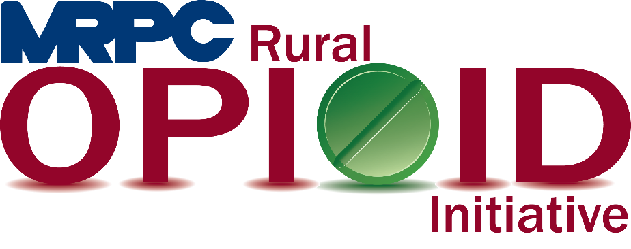

Meramec Rural Opioid Program Consortium Meeting

December 3, 2020 1:00 p.m.

Meramec Regional Planning Commission – 4 Industrial Drive, St. James, MO

Zoom Meeting

**MEMBERS PRESENT:** Greg Roeback, Jamie Myers, Sean Siebert, Felisha Richards, Charlotte Bellsmith, Chris Karr, Linda Kozlowski, Teresa Norton, Autumn Newman, Angeline Stanislaus, Jan Haviland, Mary Heywood, Sonja Williams, Beverly Williams, Micky Bowles

**STAFF PRESENT:** Samantha Maddison, Mark Perkins, Jane Johannsen, Donald Keeney

**Minutes**

1. **Call to Order and Introductions:** Samantha Maddison called the meeting to order at 1:03 p.m.
2. **OAYI Introductions:** Jane Johannsen introduced the OAYI program to the HRSA consortium by providing a quick overview of the program’s goals for this year. To be respectful of our presenter’s time, Samantha requested that the presentation be moved to the next order of business on the agenda and normal meeting activities will take place after the presentation is complete.
3. **Presentation:** Dr. Stanislaus, Chief Medical Director of the Missouri Department of Mental Health gave a presentation titled “Opioid Affected Youth – Assessing Trauma and Building Resiliency.” The presentation focused on the link between childhood trauma or PTSD and SUD, specifically alcohol use, cannabis use, and opioid use. Dr. Stanislaus spoke about how the brain is changed through trauma and the affect this has on long term decision making. One of the most important things to remember is when screening for SUD/OUD, always ask about trauma.
4. **Approval of September 29, 2020 meeting minutes:** Samantha Maddison presented the September 29, 2020 meeting minutes to the consortium for approval. Dr. Sean Siebert moved to approve the minutes and Felisha Richards seconded. Motion approved.
5. **Staff Report:** Samantha updated the consortium that MRPC is currently in the Maries County Jail to complete the entire curriculum for Seeking Safety. The program is approximately 25 weeks and should be completed mid to late February. Upon completion, the program will take place in Crawford County and Phelps County following Dr. Sean’s “Rehabilitation Through Innovation” program.
6. **Program Updates:** Members updated the group on their current efforts for the consortium and the progress they have made. Members also had the opportunity to discuss any upcoming events or opioid related programs they are working on. Members were encouraged to send any updates via email to be sent out to the entire consortium following this meeting.
   1. Your Community Health Center: Felisha reported that the summit she held in regard to maternal and fetal health in a rural setting had approximately 100 participants. The topics consisted of women’s health, pregnancy health, pregnancy and marijuana, maternity and SUD, local providers, and mothers in recovery. The mobile clinic has become very popular and is doing great in Crawford and Dent Counties. In regard to COVID, they expect to be a primary location for vaccinations.
   2. Prevention Consultants: Jamie reported to the group that Prevention Consultants is currently in Rolla Middle School and is scheduling Rolla Jr. High, Newburg, Salem, and Cuba. Jamie’s group is prepared to begin teaching virtually if that is what is necessary to continue their education programs.
   3. Phelps/Maries County Health Department: Linda reported that they have been strictly focused on COVID.
7. **Next Meetings:** Consortium will be sent a survey to schedule meeting for next quarter.
8. **Adjourn:** Felisha Richards motioned to adjourn the meeting; Jamie Myers seconded. Motion passed. Meeting was adjourned at 2:23 p.m.