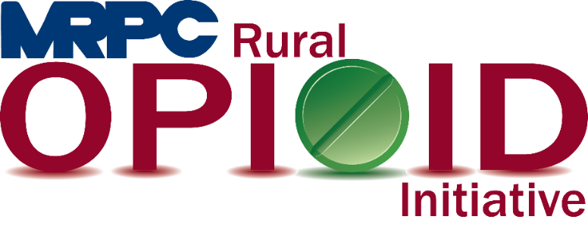

Meramec Rural Opioid Program Consortium Meeting

December 3, 2020, 1:00 p.m.

Zoom Meeting:

<https://us02web.zoom.us/j/83973320352?pwd=bmpEajVRNHVkVUN3SmtGVkNkeXBBUT09>

Meeting ID: 839 7332 0352

Passcode: 520661

1. **Call to Order and Introductions:** MRPC Staff, Samantha Maddison
2. **Approval of September 29, 2020 meeting minutes:** MRPC Staff, Samantha Maddison
3. **OAYI Introduction:** Jane Johannsen will introduce the OAYI program and give a quick overview to the group
4. **Presentation:** Dr. Stanislaus, Chief Medical Director of the Missouri Department of Mental Health will give a presentation titled “Opioid Affected Youth - Assessing Trauma and Building Resiliency”
5. **Staff Report:** MRPC staff will report on grant updates.
   1. Samantha will provide an update for the “next steps” for Seeking Safety
6. **Program Updates:** Members will update the group on their current efforts for the consortium and the progress they have made. Members will also have the opportunity to discuss any upcoming events or opioid related programs they are working on.
7. **Next Meetings:** MRPC Staff, Samantha Maddison
   1. Consortium will be sent a survey to schedule meeting for February.
8. **Adjourn:** MRPC Staff, Samantha Maddison