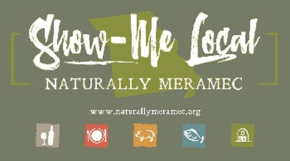2791

Naturally Meramec Consortium Regional Zoom Meeting

Tuesday, December 15, 2020 6:00 p.m.

Meramec Regional Planning Commission – 4 Industrial Drive, St. James, MO

**Agenda**

1. **Call to Order and Introductions:** Mark A. Perkins, Senior Community Development Specialist, Meramec Regional Planning Commission
2. **Approval of Minutes from the Tuesday, November 17, 2020 meeting:** Mark A. Perkins, Senior Community Development Specialist, Meramec Regional Planning Commission
3. **Staff Report:** Meramec Regional Planning Commission Staff will report on Naturally Meramec Consortium activities through Tuesday, December 15, 2020
   1. Naturally Meramec Consortium Facebook Page
   2. Naturally Meramec Consortium Website
   3. Naturally Meramec Consortium Speed-Date Event
   4. Naturally Meramec Consortium Strategic Plan
4. **Presentation:** Angie Tutterrow, CO-Owner of Go To Blu / Blu3MG
   1. “Thinking outside of the box: Is it time to pivot?”

Do you feel like your business has hit a wall? Do not give up, just add a pivot! Join Angie for an interactive presentation that will help you think outside of the box.

1. **Announcements:** Members will have an opportunity to announce special events in their areas
2. **Next Meeting:** Tuesday, January 19, 2020
3. **Networking:** Members will have an opportunity to network
4. **Adjournment:** Mark A. Perkins, Senior Community Development Specialist, Meramec Regional Planning Commission