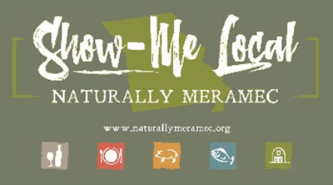2791

Naturally Meramec Consortium Regional Zoom Meeting

Tuesday, November 17, 2020 6:00 p.m.

Meramec Regional Planning Commission – 4 Industrial Drive, St. James, MO

**Agenda**

1. **Call to Order and Introductions:** Mark A. Perkins, Senior Community Development Specialist, Meramec Regional Planning Commission
2. **Approval of Minutes from the Tuesday, October 27, 2020 meeting:** Mark A. Perkins, Senior Community Development Specialist, Meramec Regional Planning Commission
3. **Staff Report:** Meramec Regional Planning Commission Staff will report on Naturally Meramec Consortium activities through Tuesday, November 17, 2020.
   1. Naturally Meramec Consortium Speed-Date Event
   2. Naturally Meramec Consortium Website
   3. Naturally Meramec Consortium Facebook Page
4. **Presentation:** Candace Connell, Business Loan Specialist, Meramec Regional Planning Commission will have a presentation about the Revolving Loan Fund. The CARES Revolving Loan Fund is a new loan program designed to provide financing for small businesses – to quickly and efficiently meet the needs of those impacted by COVID-19.
5. **Announcements:** Members will have an opportunity to announce special events in their areas.
6. **Next Meeting:** Tuesday, December 15, 2020
7. **Networking:** Members will have an opportunity to network.
8. **Adjournment:** Mark A. Perkins, Senior Community Development Specialist, Meramec Regional Planning Commission