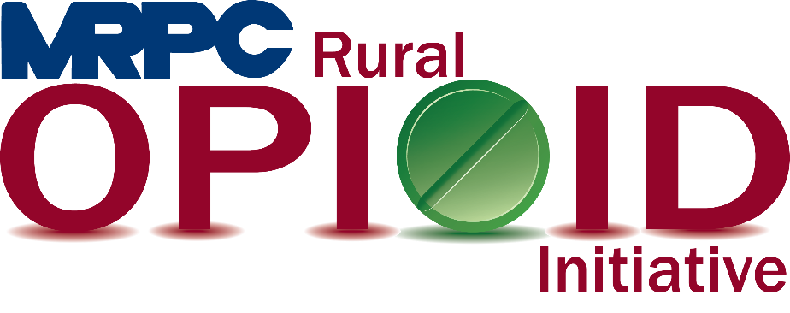

Meramec Rural Opioid Program Consortium Meeting

September 29, 2020 10:00 a.m.

Meramec Regional Planning Commission – 4 Industrial Drive, St. James, MO

**MEMBERS PRESENT:** Dr. Sean Siebert, Jamie Myers, Linda Kozlowski

**STAFF PRESENT:** Samantha Maddison, Mark Perkins, Anne Freand, Rebecca Losing, Christa Harmon

**Minutes**

1. **Call to Order and Introductions:** Samantha Maddison called the meeting to order at 10:07 a.m. Because everyone on the call with familiar with one another, introductions we not done.
2. **Approval of June 16, 2020 meeting minutes:** Samantha Maddison presented the June 16, 2020 meeting minutes to the consortium for approval. Dr. Sean Siebert moved to approve the minutes and Jamie Myers seconded. Motion approved.
3. **Staff Report:** Samantha updated the consortium that MRPC did not receive the AmerisourceBergen grant this round. MRPC was encouraged to apply again for future funding. Samantha discussed the PIMS reporting information that was sent to the group prior to the meeting. The group was asked to submit the PIMS to Samantha no later than October 16, 2020 so all information could be combined and submitted to HRSA by the deadline.
4. **Community Needs Assessment:** Samantha went over the community needs assessment with the group. She discussed the Action Items developed for the gaps and goals created from the survey results. The biggest thing on the workplan for this report is community events. This document will be used as a planning document when applying for future funding to show a need for specific services in the Meramec Region. Samantha also provided the information from the Narcan (Naloxone) Study completed in conjunction with this report. Samantha reported that while there are a large number of agencies who carry and use Narcan, there are some agencies who do not have an interest in using the medication at any point in time.
5. **Seeking Safety:** Rebecca Losing provided an update to the group on her current seeking safety program. The program is currently being taught in the Maries County Jail and is scheduled to be finished the week of October 5, 2020. There have been approximately 20 participants. Christa will be getting her certification in Seeking Safety soon and will be a back-up for the program as needed. Samantha asked the consortium for recommendations as to where the program should go next. Suggestions were made for Rebecca to reach out to the Dent County Jail or the Rolla Mission next. Dr. Siebert agreed to schedule a visit with the Dent County Jail with MRPC to schedule both events.
6. **Community Events:** Christa provided the consortium with an update of the Awareness Walks that have been held in Crawford, Dent, and Phelps counties. Walk in St. James, Steelville, and Salem have brought together over 100 people, Steelville being the largest group. Christa then talked to the consortium about the walk taking place in Belle on Saturday October 3, 2020. Registration begins at 9:00 a.m. and the walk begins at 10:00 a.m. Walk takes place rain or shine.
7. **Year 3 Updates:** Samantha provided an overview of the workplan for Year 3. Dr. Sean and Jamie Myers confirmed they are on track with their workplan items for the remainder of the program. Samantha updated the group that the consortium will need to review and update the strategic plan created at the beginning of the grant. Samantha will schedule a meeting within the next month to update the plan. Samantha spoke to the consortium about the morbidity and mortality review for 2020. The document is currently being reviewed and will be provided to the public soon. Samantha and Rebecca have been working on the workshop that is now scheduled for March/April 2021. MRPC staff are currently reaching out to employers in the region to help narrow down presentation topics. More information will be provided as the planning phase progresses.
8. **Program Updates:** Members updated the group on their current efforts for the consortium and the progress they have made. Members also had the opportunity to discuss any upcoming events or opioid related programs they are working on. Members were encouraged to send any updates via email to be sent out to the entire consortium following this meeting.
   1. Prevention Consultants: Jamie reported to the group that Prevention Consultants is currently in Rolla Middle School and is scheduling Rolla Jr. High, Newburg, Salem, Edgar Springs, Bourbon, Cuba, and Potosi. Jamie’s group is prepared to begin teaching virtually if that is what is necessary to continue their education programs.
   2. Invent Yourself, LLC: Dr. Siebert is currently teaching his program at The Rolla Mission. He is hopeful to get into Dent County shortly and complete two programs in year three. Crawford County is currently on hold due to COVID-19 issues so Sean indicated he may look into a Celebrate Recovery program instead of the jail. He expects to complete a program in Phelps County in early spring. Sean does not have a date yet for Maries County but would like to complete the program in the jail again.
9. **Next Meetings:** Consortium will be sent a survey to schedule meeting for next quarter (November or December).