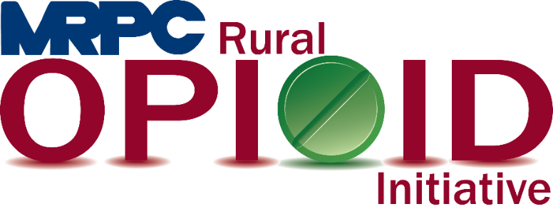

Meramec Rural Opioid Program Consortium Meeting

September 29, 2020, 10:00 a.m.

Zoom Meeting:

<https://us02web.zoom.us/j/82022547883?pwd=d1BHejJMSkpvditsV1ZCM2g4OXZ0QT09>

Meeting ID: 820 2254 7883

Passcode: 819443

1. **Call to Order and Introductions:** MRPC Staff, Samantha Maddison
2. **Approval of June 16, 2020 meeting minutes:** MRPC Staff, Samantha Maddison
3. **Staff Report:** MRPC staff will report on grant updates.
   1. Samantha will update the group on the Amerisource Bergen Grant application status.
   2. Samantha will discuss the upcoming PIMS reporting that was sent earlier this month. Please complete the PIMS report and send to Samantha no later than October 16th.
4. **Community Needs Assessment:** MRPC Staff, Samantha Maddison
   1. Consortium will review the results of the Community Needs Assessment.
5. **Seeking Safety Update:** MRPC Staff, Rebecca Losing
   1. Rebecca will provide the group with an update of the classes she has completed so far in the Maries County Jail.
6. **Community Events Update:** MRPC Staff, Christa Harmon
   1. Christa will provide the group with an update on the three substance abuse awareness walks that have taken place and then provide information on the upcoming event in Belle on October 3 at 9:00 a.m.
7. **Year 3 Activities:** MRPC Staff, Samantha Maddison
   1. Samantha will provide an overview of the current list of activities planned for Year 3.
8. **Program Updates:** Members will update the group on their current efforts for the consortium and the progress they have made. Members will also have the opportunity to discuss any upcoming events or opioid related programs they are working on.
9. **Next Meetings:** MRPC Staff, Samantha Maddison
   1. Consortium will be sent a survey to schedule meeting for November or December.
10. **Adjourn:** MRPC Staff, Samantha Maddison