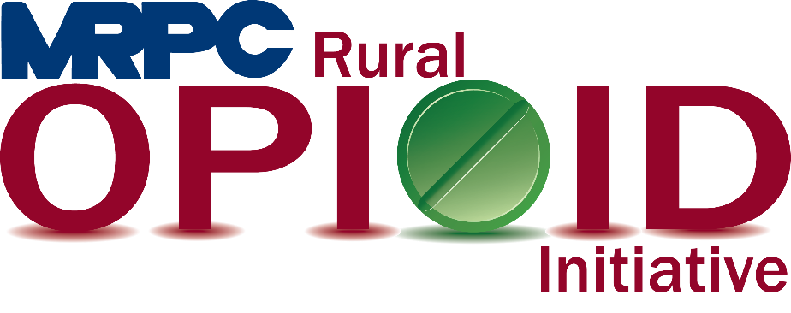

Meramec Rural Opioid Program

Consortium Meeting

June 16, 2020

Meramec Regional Planning Commission, 4 Industrial Drive, St. James, MO

1:00 p.m.

Meeting Minutes

1. **Call to Order and Introductions:** Samantha Maddison called the meeting to order at 1:06 p.m. and all attendees introduced themselves. Samantha asked for approval to move item 6, seeking safety, before item 4, strategic plan.
2. **Approval of January 16, 2020 meeting minutes:** Samantha Maddison presented the January 16, 2020 meeting minutes to the consortium for approval. Dr. Sean Siebert moved to approve the minutes and Felisha Richards seconded. Motion approved.
3. **Staff Report:** Because Samantha had Christa introduce herself at the beginning of the meeting, Christa was not introduced again. Samantha updated consortium on the contingency plan for social media that MRPC created. MRPC put a focus on three main categories; Where meeting are being held virtually, facts about substance use and recovery, and a youth focus. Samantha provided information about the AmerisourceBergen grant that MRPC applied for earlier this year. The grant application is focused on a strategic plan in the four counties that HRSA does not include, prescription drug storage containers, morbidity and mortality review, awareness activities, GIS mapping services, and expansion on the MRPC Rural Opioid Initiative webpage. Samantha also provided a quick update of the website and its features.
4. **Seeking Safety:** Rebecca Losing provided an update about what the Seeking Safety program consists of. She included a sample lesson for the group to look at. She asked for suggestions on where we could implement the first program and Dr. Siebert felt that we could start the program in the Maries County Jail as soon as his program is done. Rebecca and Samantha will reach out to Sheriff Heitman to see if this is a possibility.
5. **Strategic Plan:** Anne provided a copy of the CEDS benchmark report to provide an idea of how we would like to track our goals and objectives of the strategic plan. Samantha provided the original goals and objectives of the strategic plan to the group. The strategic plan will be sent out to the consortium to review the current objectives and make any additions as suggested. Anne suggested that additional meetings be held to update the strategic plan in the next quarter.
6. **Community Needs Assessment:** Samantha went over the community needs assessment with the group. She discussed the assessment methodologies and who was interviewed for this process. Those interviewed included law enforcement, first responders, schools, and pharmacies. Pharmacies were not willing to participate in the surveys. Samantha discussed some of the results from the surveys with the group. She indicated that currently Meth is the most commonly seen drug, but this changes regularly because when the use of one drug increases, another decreased. Samantha also discussed service gaps in the Meramec Region. Those gaps included not having consistent processes when encountering an individual under the influence, not all counties have a drug court, not all counties and cities have Narcan, not all schools have an SRO, and there is no consistent prevention education program being taught in schools. Samantha also presented the goals developed from the CNA. Those goals are combating the SUD stigma in our rural communities, increasing opportunities for employment, implementing early prevention strategies, and fostering strong recovery systems. Samantha briefly went over the implementation plan but decided to send the list to the group to review and make suggestions at their convenience.
7. **Community Events:** Christa and Rebecca gave a brief update of the 2020 Belle Swap Meet and Extravaganza. They provided information about the two opioid grants that MRPC is currently working on. The event was well attended by the community. Samantha asked that the group send any information about upcoming events for us to attend.
8. **Program Updates:** Due to the length of time spent on the Community Needs Assessment and the OJJDP grant discussions, updates were not given. Members were encouraged to email any pressing information they have to Samantha and she will send it to the consortium.
9. **Next Meetings:** Consortium will be sent a survey to schedule meeting for next quarter.