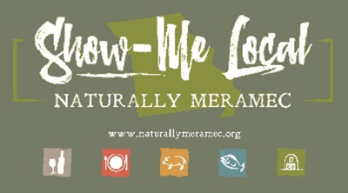2791

Naturally Meramec Consortium Regional Zoom Meeting

Tuesday, January 26, 2021 6:30 p.m.

Meramec Regional Planning Commission

Via Zoom Conference Video/Call

Join Zoom Meeting

<https://us02web.zoom.us/j/89429867495?pwd=UlJXWXpweVEvK1M4NW1td2Z3djA3Zz09>

Meeting ID: 894 2986 7495

Passcode: 429679

+13126266799,89429867495#, *429679# US (Chicago)

+19292056099,89429867495#, *429679# US (New York)

Dial by your location.

+1 312 626 6799 US (Chicago)

Meeting ID: 894 2986 7495

Passcode: 429679

**Agenda**

1. **Call to Order and Introductions:** Mark A. Perkins, Senior Community Development Specialist, Meramec Regional Planning Commission
2. **Approval of Minutes from the Tuesday, December 15, 2020 meeting:** Mark A. Perkins, Senior Community Development Specialist, Meramec Regional Planning Commission
3. **Staff Report:** Meramec Regional Planning Commission Staff will report on Naturally Meramec Consortium activities through Tuesday, January 26, 2021
   1. Naturally Meramec Consortium Facebook Page
   2. Naturally Meramec Consortium Website
   3. Naturally Meramec Consortium Speed-Date Event
   4. Naturally Meramec Consortium Strategic Plan

The Meramec Regional Planning Commission Staff has created a Naturally Meramec Consortium (NMC) Business Survey to gather information through one-on-one meetings with NMC members to begin identifying needs of the NMC.

1. **Presentation:** Sarah Hultine Massengale, PhD, County Engagement Specialist in Community Economic Development of University of Missouri Extension in Dent County
   1. “Exploring Food System Resources from University of Missouri Extension”

Food systems encompass all the people, processes and infrastructure involved in getting food from the farm to your table. Whether you are a farmer or food business owner, consumer, or community leader ─ see what MU Extension offers through tools, programs, and partnerships to help strengthen your community food system for thriving food business, safe and affordable food sources for all, stewardship of natural resources, and resilient community relationships. New tools and upcoming trainings will be featured.

1. **Presentation:** Monica Harris, Business Developer of Caledon Virtual
   1. “The Foundations That Remain Relevant: Best Strategies For Growth”

There are proven strategies for digital marketing that remain solid, however consumers are changing and adapting with the times. How do we, as a business, respond and succeed?

1. **Announcements:** Members will have an opportunity to announce special events in their areas
2. **Next Meeting:** Tuesday, February 23, 2021
3. **Networking:** Members will have an opportunity to network
4. **Adjournment:** Mark A. Perkins, Senior Community Development Specialist, Meramec Regional Planning Commission