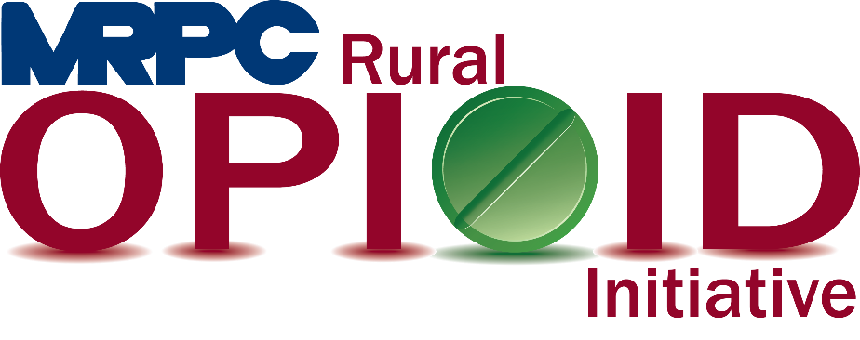

Meramec Rural Opioid Program Consortium Meeting

June 16, 2020, 1:00 p.m.

Zoom Meeting:

<https://us02web.zoom.us/j/88181141415?pwd=L3Q5SjZPNmtwRmY5N3pONTF1NUtMZz09>

Meeting ID: 881 8114 1415

Password: 269765

1. **Call to Order and Introductions:** MRPC Staff, Samantha Maddison
2. **Approval of January 16, 2020 meeting minutes:** MRPC Staff, Samantha Maddison
3. **Staff Report:** MRPC staff will report on grant updates.
   1. Samantha will introduce the new employees to the consortium.
   2. Samantha will update the group on the new Amerisource Bergen Grant application.
4. **Strategic Plan:** MRPC staff, Samantha Maddison and Anne Freand
   1. Consortium will review the goals and objectives of the Strategic Plan
5. **Community Needs Assessment:** MRPC Staff, Samantha Maddison
   1. Consortium will review the DRAFT Community Needs Assessment.
6. **Seeking Safety:** MRPC Staff, Rebecca Losing
   1. MRPC Staff will speak about “Seeking Safety”, a curriculum for those who suffer from PTSD and Substance Use Disorder and ask for recommendations of groups to meet with.
7. **Community Events:** MRPC Staff
   1. Staff will update consortium on the Belle Swap Meet & Extravaganza they attended on June 13, 2020.
8. **Program Updates:** Members will update the group on their current efforts for the consortium and the progress they have made. Members will also have the opportunity to discuss any upcoming events or opioid related programs they are working on.
9. **Next Meetings:** MRPC Staff, Samantha Maddison
   1. Consortium will be sent a survey to schedule meeting for August or September.