Meramec Regional Planning Commission
Minutes
August 8, 2019

Call to Order
Vice Chairman Steve Vogt called the Aug. 8, 2019, meeting of the Meramec Regional Planning Commission to order at 7:35 p.m.

Welcome
Chairman Miskel welcomed everyone to the meeting and introductions were made around the room. A get well card for MRPC board member Ron Kraettli, who had surgery yesterday, was passed around for board members to sign.

Consent Agenda
The following consent agenda items are presented for approval:

a. Minutes – June 13, 2019

b. Local Review
- Phelps County Committee to Prevent Child Abuse, Rolla, MO
93.276 – Drug-Free Communities Support Program Grants
Phelps County, Missouri Drug Free Communities Program
Federal: $125,000
Applicant: $132,139
Total: $287,139

c. Statewide Grant Applications
- Missouri State Department of Agriculture
10.025 – Plant and Animal Disease, Pest Control, and Animal Care
FY19 Animal Health National Surveillance and Response activities
Total: $308,720

- Missouri Department of Natural Resources, Jefferson City, MO
66.605 – Performance Partnerships Grants
FY 2020-2021 – Performance Partnership Grant – work plans may be submitted separately
Federal: $26,144,690
Applicant: $1,208, 766
Total: $36,353,456

The Office of Administration issues the Missouri Federal Assistance Clearinghouse
grant reviews weekly. Staff will share reports in between meetings with board members. If you have questions about grants listed, you can call MRPC staff or the Office of Administration as listed on the reports.

d. Contracts
- Missouri Office of Homeland Security
Permission is requested for MRPC/s chairman and/or executive director to enter into a grant agreement with Office of Homeland Security for the FY19 Region I HSOC grants and sign all necessary paperwork. Permission is also requested for MRPC/s chairman and/or executive director to allocate Region I HSOC grant funds based on the recommendations from the Region I HSOC board and to sign the necessary paperwork to enter into subaward agreements with grant recipients. The Region I HSOC made the following recommendation at its meeting on July 25:
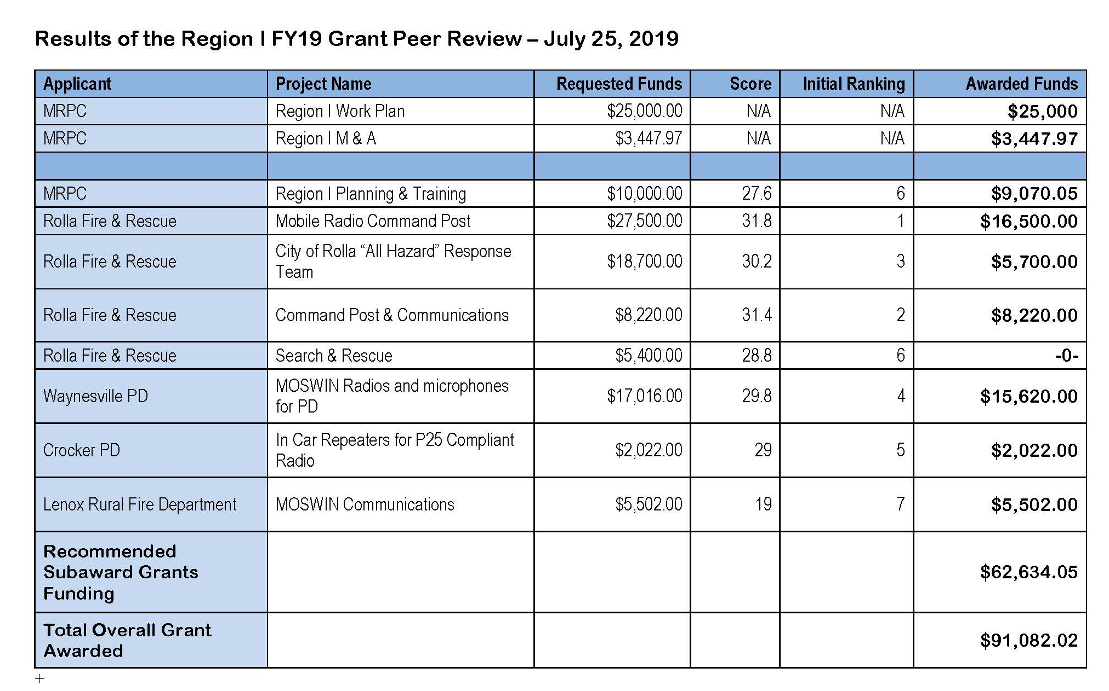
- City of Bland
Permission is requested for MRPC’s chairman and/or executive director to enter into a contract with the City of Bland for housing inspection services, and for MRPC’s chairman and/or executive director to sign any necessary documents.

- Permission is requested for staff to submit the Chemical Emergency Preparedness Fund (CEPF) grant application to the Missouri Emergency Response Commission for emergency planning assistance to cities and counties in the region through the Local Emergency Planning Committee—MREPC, and for staff to obtain all appropriate official signatures.

- City of Salem
Permission is requested for MRPC’s chairman and/or executive director to enter into a technical assistant contract for application preparation with the City of Salem for a Community Development Block Grant (CDBG), and for MRPC’s chairman and/or executive director to sign any necessary documents.

- Salem R-80 School District
Permission is requested for MRPC’s chairman and/or executive director to enter into a technical assistant contract for application preparation with a Youth Opportunity Program Workforce Initiative for the Salem R-80 School District, and for MRPC’s chairman and/or executive director to sign any necessary documents.

- State Regional Planning Commission Grant Application
Permission is requested for MRPC to submit the grant application to the Missouri Office of Administration for the State Regional Planning Commission Grant, and authorization is requested for the executive director and/or MRPC’s chairman to sign the application. Permission is also requested for the executive director and/or chairman to sign a grant agreement and any related documents should the grant be funded.

- Invent Yourself, LLC
Permission is requested for MRPC’s chairman and/or executive director to enter into a contract with Invent Yourself, LLC to provide “Lunch and Learn” workshops through a USDA-FMPP grant and for MRPC’s chairman and/or executive director to sign any necessary documents. Invent Yourself, LLC was identified as a subcontractor in the grant application.

T.R. Dudley made a motion to approve the consent agenda with the noted additions; Gary Brown seconded. The motion carried.

Presentation: Natascha Lord, Trade Specialist with International Trade and Investment Office, Missouri Department of Economic Development
Natascha Lord, Trade Specialist with the Missouri International Trade and Investment Office, DED, provided information on export training and trade activities designed to promote Missouri-made goods.

Ms. Lord informed the board that there are 12 foreign offices which can provide the following services, free of charge, to Missouri businesses wanting to export their goods.
- Agent distributor search (flagship product of her office that assists in finding international customers)
- Conducting background checks
- Customizing marketing and research
- Issuing certificates of free sale
- Export financing (there are two grant programs that business can apply to)
- Customizing company missions (setting up appointments with potential partners)
- Transportation and logistics
- Interpretation services

Of these services, Ms. Lord noted that the biggest asset to Missouri companies is the assistance in setting up appointments with potential partners.

Ms. Lord stated that in 2018, Missouri’s businesses exported $14.5 billion dollars in goods. The top two exports in Missouri were transportation equipment and chemicals. In the MRPC region, the top two exports were computer and electronic products and chemicals. She also noted that most of the exported goods were going to Canada ($57.98 million), Mexico ($51 million) and China ($32.22 million).

She provided information on export numbers for the counties in the Meramec Region.
- Crawford County - $77.11 million
- Osage County - $47.54 million
- Phelps County - $44.33 million
- Dent County - $33.54 million
- Maries County - $23.97 million
- Gasconade County - $22.04 million
- Washington County - $9.65 million
- Pulaski County - $4.92 million

Information was also provided by Ms. Lord on two programs available to small businesses. The State Trade and Export Program (STEP). Through the STEP program, businesses can apply for funding to booster their exports by participating in foreign trade missions and market sales trips, subscriptions services provided by the U.S. Department of Commerce, website foreign language translation services, design of international marketing materials, trade show exhibitions, and participation in export and trade financing workshops. The Global Market Access Program (GMAP) is a state program that provides financial assistance for businesses to participate in trade shows and missions and market their goods to a worldwide audience. Ms. Lord informed the board that Missouri businesses could qualify for up to $15,000 for each program, for a total of $30,000 for marketing each year.

Ms. Lord concluded her presentation by providing her contact information and brochures on the Missouri export program. She encouraged the board members to visit the website for more information (www.exportmissouri.mo.gov).

MRPC board member Jim Fleming stated that he had participated in a trade show in Dubai when he was with Tacony Manufacturing. He indicated that the $15,000 paid for the company’s trade booth and staff to work the booth.

Ms. Lord will provide Ms. Prigge with copies of the county level data that will then be shared out to all board members.

Randy Verkamp asked about markets in China. Ms. Lord indicated that there has been a downward trend in companies looking to market goods in China.

Legislative Guests
Ray Bozarth with Senator Josh Hawley’s office reported that an agreement has been reached on a debt cap. He also indicated that Senator Hawley is watching BRO and that top leaders in the Senate and House have endorsed the repeal of the BRO recension.

He noted that MoDOT transportation received an $81 million infrastructure grant from the U.S. Department of Transportation which freed up the bonded $300 million for bridge projects. This will allow for the replacement of the Rocheport Bridge between Boonville and Columbia.

Mr. Bozarth said that both Democrats and Republicans agree that prescription drug prices are too high. He went on to say that Senator Hawley co-sponsored legislation with Senator Rick Scott from Florida, which would index American pharmaceuticals prices with international prices. Prescription drug prices overseas are considerably lower.

Mr. Bozarth reported that Senator Hawley, along with Senator Tammy Baldwin from WI, introduced the Competitive Dollar for Jobs and Prosperity Act. This act is designed to manage the U.S. dollar exchange rate and bring it into alignment to restore fairness to international trade markets. Mr. Bozarth indicated he would send more detailed information to Ms. Prigge to share out to the board.

He informed the board that bringing jobs back to Missouri is key issue for Senator Hawley. He also noted that legislators would be back in session the second week of September.

External Relations Committee: Leo Sanders
In the absence of the chairman, and vice chairman Ray Schwartze reported on External Relations activities as follows:

Staff provided information on entertainment at the annual dinner and was shown a working cover of the annual report.

Committee members discussed options for the October MRPC meeting and are recommending an abbreviated meeting with no committee meetings or dinner. Chairman Schwartze made a motion to hold an abbreviated October meeting; Gary Brown seconded. The motion carried.

Staff provided a copy of the Hour Allocation Policy Change for review and approval. Chairman Schwartze made a motion to approve the policy change; T.R. Dudley seconded. The motion carried.
Ms. Snodgrass reported on the recent board orientation.

Ms. Snodgrass informed the committee that the MRCF board had an opening and that a volunteer from the MRPC board was needed to fill that position.

Ray Bozarth with Senator Josh Hawley’s office provided an update on recent activity in the Senator’s office.

A report was provided by staff on state and/or federal legislative issues that occurred since the last board meeting.

Operations Committee: Steve Vogt, chairman
Chairman Steve Vogt reported on operations activities as follows:

The committee reviewed the preliminary year-end MRPC/MRB and MRPC/MRDC-RLF and IRP program financial statements for the period ending May 31, 2019. Staff will also present MRPC/MRB and MRPC/MRDC-RLF and IRP program financial statements for the period ended July 31, 2019.

Chairman Vogt made a motion to accept the preliminary year-end financials for the period ending May 31, 2019; Randy Verkamp seconded. The motion carried.
Chairman Vogt made a motion to accept the financials for the period ending July 31, 2018; John Casey seconded. The motion carried.

The committee reviewed salary ranges from the recently completed salary comparison. Chairman Vogt made a motion to accept the updated ranges; Randy Verkamp seconded. The motion carried.

The committee reviewed a recommendation from Meramec Regional Development Corporation to provide EDA RLF financing to Park Street Tire in Salem. The purchase is for land, building, and fixed assets. The RFL portion is $73,000. Chairman Vogt made a motion to approve the financing; Jim Fleming seconded. The motion carried.

Planning Committee: T.R. Dudley
Chairman T.R. Dudley reported on planning activities as follows:

Staff provided an overview on the summer entrepreneurship project between MRPC and MS&T.
Samantha Maddison and Mark Perkins, MRPC, provided an overview of the Naturally Meramec Food Hub Feasibility Study. This project brings producers and buyers together and provides an opportunity for them to discuss the challenges in their sectors. The next Naturally Meramec meeting will be on July 25 at the MRPC office.

The committee discussed strategic planning, both very basic planning and on up to more comprehensive planning, and the impacts it can have on communities. A strategic plan is a good to tool to use when applying for grants.

Staff updated the committee on the next round of Meramec Mornings and the topic of different types of planning. Chairman Dudley encouraged board members to attend the Meramec Mornings.

Housing Advisory Board: Randy Verkamp, chairman
No report was given.

Transportation Advisory Committee: Ray Walden, chairman
Chairman Ray Walden reported on transportation activities as follows:

Dave Silvester, MoDOT, gave an update on the Missouri Infra Grant for replacement of the Rocheport Bridge. Steve Engelbrecht, MoDOT, provided an update on the 2020-2024 STIP stating that details could be found on the MoDOT website.

Anne Freand, MRPC, provided an update on the Planning Framework committee meeting held just prior to today’s TAC meeting.

Bonnie Prigge, MRPC, gave an update on the upcoming grant period and requirements for the Federal Lands Access Program (FLAP).

An update on the Arrive Alive program was provided by Ms. Prigge and information on availability of Buckle Up/Phone Down (BUPD) signage was provided to board members. Signs are available at no cost to private or public businesses. Ms. Prigge asked members to reach out to schools in their area to get their signs updated. Caitlin Jones, MRPC, added that MRPC has stencils available for use on parking lots if anyone was interested.

Ms. Freand shared the findings from the Gasconade County Road Safety Audit held on June 18. 2019.

MoDOT staff provided updates on local projects and funding, including information on TEAP funds.

Environmental:
The board was provided with a handout, covering environmental updates as well as updates on Meramec Regional Emergency Planning and Homeland Security Oversight Committee activities.

Tammy Snodgrass reminded the board that Ozark Rivers grant applications are due Aug. 23 at noon and award nominations for Outstanding Contributions in Solid Waste Management are due Sept. 25.

Ms. Snodgrass informed the board that there haven’t been a lot of good responses. The survey looks at ways small wastewater systems can share an operator.

Meramec Regional Emergency Planning Committee:
Updates were included on the environmental handout that was provided.

Business Loans: Linda Loughridge, Fiscal Officer
Linda Loughridge reported that MRDC’s next board meeting will be the annual meeting on Aug. 21.

A handout was provided showing the status and balance of loans in SBA, RLF and IRP. It was also noted that the SBA 504 program has some great rates right now.

Workforce Development: T.R. Dudley
T.R. Dudley provided an update on workforce development activities.

Mr. Dudley gave a brief update concerning recent issues within the Central Workforce Development Board. The CWIB experienced a budget shortfall due to mismanagement and lack of oversight, which resulted in the closure of satellite and career centers and reduction in staff. He stated that there is a push to move the entire Central Office to Jefferson City but there is on-going discussion for a compromise, where some staff would be housed in Rolla.
Mr. Dudley thanked everyone for their support and indicated he would continue to provide updates.

Meramec Community Enhancement Corporation: Vic Stratman
No report was given.

Meramec Region Community Foundation (MRCF):
Bonnie Prigge reported that the next meeting will be the annual meeting on Aug. 29 at 1:30 p.m. She asked that board members think about volunteering to fill the MRPC representative position on the MRCF board.

Vice Chairman Report:
No report given.

Director Report:
Bonnie Prigge reported that four or five board members attended the recent board orientation. She also informed the board that dues letters would be going out next week and the amounts shown include the 3% increase.

Ms. Prigge reminded the board that an Elected Officials Workshop is scheduled for Aug. 22 and reservations are due tomorrow.

The second round of Meramec Mornings has been completed and Ms. Prigge reported that approximately 60 individuals were in attendance over the eight meetings. The next round will focus more on planning.

Ms. Prigge reminded members that the October meeting schedule will be as follows:
3:00 p.m. – TAC subcommittee
4:00 p.m. – TAC
5:30 or 6:00 p.m. – MRPC abbreviated meeting with essential items only; no committee meetings or meal

Ms. Prigge informed board members that MRPC will cover the cost of the annual dinner ticket for all award winners. She added that the local community usually covers the ticket cost for a spouse or guest, but that is a local decision.

Ms. Prigge and other members of the MRPC staff recently made a visit to Stonebrook Center to view the site in advance of the annual dinner. Since this year marks MRPC’s 50th Anniversary, Caitlin Jones is putting together a slideshow on the organization’s history. If anyone has any photos from their time on the board and don’t mind sharing them, they were asked to reach out to her.

Ms. Prigge informed the board the Dave Silvester, the MoDOT district engineer for the Central Region, has been promoted to the Kansas City office.

Ms. Prigge reported that she and Tammy Snodgrass would be attended EDA training in Denver during the last week of August.

Miscellaneous:
Alan Galindo informed the board that as of Aug. 31 he will be leaving the workforce board. He thanked everyone for their support and stated he would be transitioning the NEXUS meetings and other projects to the workforce coordinators.

Mr. Dudley noted that Alan has been an exemplary employee in the workforce office and Ms. Prigge thanked Alan for his assistance and commitment to MRPC.

Adjourn
Steve Vogt made a motion to adjourn the meeting at 8:51p.m.; John Casey seconded the motion. The motion carried.

_____________________________________ ________________________________
Larry Miskel, chairman Attest

