DATE: July 31, 2019
TO: MRPC Board of Commissioners
FROM: Larry Miskel, Chairman
SUBJECT: Meeting Notice and Agenda

The Meramec Regional Planning Commission will hold a public meeting on Thursday, Aug. 8, 2019, at its office, located at 4 Industrial Drive, St. James, Missouri. The meeting schedule is as follows:

4:00 p.m. TAC (Large Conference Room)
6:00 p.m. External Relations/Membership Committee (Large Conference Room - East Side)
6:00 p.m. Operations Committee (Small Conference Room)
6:00 p.m. Planning Committee (Large Conference Room – West Side)
7:00 p.m. Dinner
7:30 p.m. MRPC (Large Conference Room)

Agenda
1. Pledge of Allegiance

2. Welcome: Steve Vogt, vice chairman

3. Consent Agenda

The consent agenda is intended to group several items of a routine nature upon which the commission agrees to accept a committee or staff recommendation. Listed below are the items on the consent agenda. A motion may be made to accept all the items listed, or if a commissioner wishes to consider any item(s) separately, then a motion would be in order to approve the consent agenda with the exception of the item(s) to be considered separately. Any item to be considered separately would then be taken up immediately after the consent agenda is adopted.

The following consent agenda items are presented for approval:

a. Minutes – June 13, 2019

b. Local Review
None for review

c. Statewide Grant Applications
- Missouri State Department of Agriculture
10.025 – Plant and Animal Disease, Pest Control, and Animal Care
FY19 Animal Health National Surveillance and Response activities
Total: $308,720

The Office of Administration issues the Missouri Federal Assistance Clearinghouse
grant reviews weekly. In the future, staff will share reports in between meeting with board members. If you have questions about grants listed, you can call MRPC staff or the Office of Administration as listed on the reports

e. Contracts
- Missouri Office of Homeland Security
Permission is requested for MRPC/s chairman and/or executive director to enter into a grant agreement with Office of Homeland Security for the FY19 Region I HSOC grants and sign all necessary paperwork. Permission is also requested for MRPC/s chairman and/or executive director to allocate Region I HSOC grant funds based on the recommendations from the Region I HSOC board and to sign the necessary paperwork to enter into subaward agreements with grant recipients. The Region I HSOC made the following recommendation at its meeting on July 25:
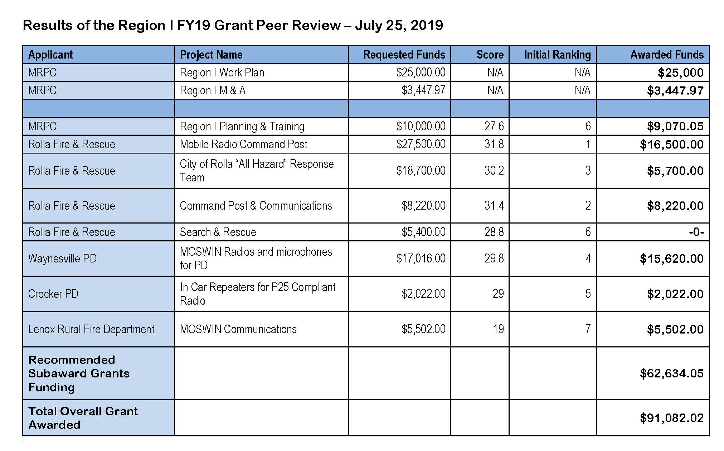
- City of Bland
Permission is requested for MRPC’s chairman and/or executive director to enter into a contract with the City of Bland for housing inspection services, and for MRPC’s chairman and/or executive director to sign any necessary documents.

- Permission is requested for staff to submit the Chemical Emergency Preparedness Fund (CEPF) grant application to the Missouri Emergency Response Commission for emergency planning assistance to cities and counties in the region through the Local Emergency Planning Committee—MREPC, and for staff to obtain all appropriate official signatures.

- City of Salem
Permission is requested for MRPC’s chairman and/or executive director to enter into a technical assistant contract for application preparation with the City of Salem for a Community Development Block Grant (CDBG), and for MRPC’s chairman and/or executive director to sign any necessary documents.

- Salem R-80 School District
Permission is requested for MRPC’s chairman and/or executive director to enter into a technical assistant contract for application preparation with a Youth Opportunity Program Workforce Initiative for the Salem R-80 School District, and for MRPC’s chairman and/or executive director to sign any necessary documents.

- State Regional Planning Commission Grant Application
Permission is requested for MRPC to submit the grant application to the Missouri Office of Administration for the State Regional Planning Commission Grant, and authorization is requested for the executive director and/or MRPC’s chairman to sign the application. Permission is also requested for the executive director and/or chairman to sign a grant agreement and any related documents should the grant be funded.

4. Presentation: Natascha Lord, Trade Specialist with International Trade and Investment Office
Natasha Lord, will discuss the State Trade and Export Promotion (STEP) grant program, administered by the Department of Economic Development’s International Trade and Investment Office. Ms. Lord will provide information on how the program can assist small businesses with export training, connecting with new clients internationally and trade activities to promote Missouri-made goods.

5. Update from state legislators and/or federal congressional liaisons

6. Board and Committee Reports:

- External Relations Committee: Darrell Skiles, chairman

The External Relations/Membership Committee will consider meeting format for October meeting. The committee will review the updated hour allocation policy and staff will report on the July 31st board orientation. The committee will discuss the meeting schedule with state and federal legislators and begin discussion on state priorities for the 2020 legislative session. Board action on October meeting schedule and hour allocation policy will be requested.

b. Operations Committee: Steve Vogt, chairman

The Operations Committee will review MRPC/MRB preliminary year-end financial statements and MRPC/MRDC-RLF & IRP preliminary year end program financial statements for the period ending June 30, 2019. Staff will also present MRPC/MRB and MRPC/MRDC-RLF and IRP program financial statements for the period ended July 31, 2019. Salary ranges for all MRPC positions will be presented for approval as a result of the salary comparison conducted. The committee will request board action on minutes, financials and salary ranges.

Committee will also consider a recommendation from Meramec Regional Development Corporation to provide EDA RLF financing to Park Street Tire in Salem. Committee will make a recommendation to the full board for action.

- Planning Committee: T.R. Dudley, chairman

The Planning Committee will discuss strategic planning and the impacts it can have on communities within the region. The committee will discuss planning for organizations and businesses versus neighborhoods and cities, and the various ways that strategic planning can be accomplished. Staff will update the committee on the next round of Meramec Mornings and the topic of different types of planning.

Housing Advisory Board: Randy Verkamp, chairman

No report will be given.

- Transportation Advisory Committee: Ray Walden, chairman

Ray Walden will report on transportation activities.

f. Environmental: Tammy Snodgrass, Assistant Director

Tammy Snodgrass will report on solid waste activities.

g. Meramec Regional Emergency Planning Committee: Tammy Snodgrass

Tammy Snodgrass will report on MREPC activities.

h. Business Loans: Linda Loughridge, Fiscal Officer

Linda Loughridge will report on business loan activities.

i. Workforce Development: T.R. Dudley

T.R. Dudley will report on workforce development activities.

j. Meramec Community Enhancement Corporation (MCEC): Vic Stratman

Vic Stratman will report on MCEC activities.

k. Meramec Regional Community Foundation (MRCF): Bonnie Prigge, Executive Director

Bonnie Prigge will report on MRCF activities.

l. Vice Chairman and Director’s Report:

Steve Vogt and Bonnie Prigge will report on issues of interest.

7. Adjourn

8. Informational Agenda
Contracts signed by the Executive Director as amount was under the $3,000 threshold:

● St. James Caring Center
June 26, 2019: MRPC Executive Director entered into a contract with St. James Caring Center to perform an asbestos inspection, for renovation activities on the interior of the Caring Center building.

● City of West Plains
July 1, 2019: MRPC Executive Director entered into a contract with the City of West Plains to perform an asbestos inspection for four structures located at 1807, 1809, 812 and 1815 Worel St., West Plains, MO.

● City of Belle
July 1, 2019: MRPC Executive Director entered into a contract with the City of Belle to perform housing inspection services.

● Douglas County, MO
July 24, 2019: MRPC Executive Director entered into a contract with the Douglas County, MO to perform asbestos inspection services on a structure located at HC 71, Box 144-Z, CR-A, 409, Ava, MO.

● Mountain Grove Love Center Food Pantry
July 24, 2019: MRPC Executive Director entered into a contract with the Mountain Grove Love Center Food Pantry in Mountain Grove, MO to perform asbestos inspection services on a structure located at 304 1st Street, Mountain Grove, MO.

The following staff members have prepared handout reports:
• Kelly Sink-Blair—grants submitted and funded since the last meeting, application deadlines and funding availability.
• Tammy Snodgrass— solid waste activities, emergency planning and management, Homeland Security Oversight Committee activities, hazard mitigation and pending grant applications.
- Linda Loughridge—Hour allocation tracking sheet will be handed out.

