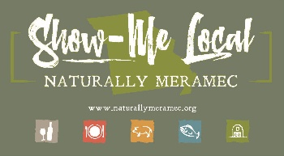

Naturally Meramec Consortium

Regional Meeting

September 26, 2019

Meramec Regional Planning Commission, 4 Industrial Drive, St. James, MO

6:00 p.m.

Meeting Minutes

**Call to Order:** Samantha Maddison called the meeting to order at 6:15 p.m.

**Approval of Minutes from the August 29, 2019 meeting:** Samantha Maddison presented the minutes for approval. John Gulick made a motion, seconded by Angie Tutterrow, that the minutes be approved as presented. Motion passed.

**Staff Report:** Samantha Maddison provided an update to the consortium on the upcoming events for Naturally Meramec. She let the group know that Mark will be at Wenwood Winery this coming weekend, September 28th, for an all day event.

**Food Hub Feasibility Study SWOC Analysis:** Samantha Maddison gave everyone a copy of the SWOC that the previous meeting attendees prioritized and asked them to look it over. They were told to please email any questions or comments they had about the lists if they felt something was not correct.

**Distribution of Products:** St. James Winery did not attend the meeting. They will present at the November meeting.

**Announcements:** The Naturally Meramec Consortium attendees were able to make any announcements about their business and discuss any upcoming events.

**Next Meeting:** The next Naturally Meramec Consortium Regional Meetings are scheduled for Thursday, November 7, 2019 at 6:00 p.m. and December 5, 2019 at 6:00 p.m.

**Networking:** After the meeting, Naturally Meramec Consortium attendees were able to network with other attendees.

**Adjournment:** John Gulick made a motion to adjourn, seconded by Marie Selfors. Motion passed.