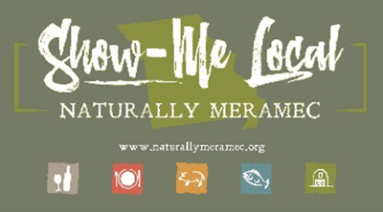

Naturally Meramec Consortium

Regional Meeting

November 7, 2019

Meramec Regional Planning Commission, 4 Industrial Drive, St. James, MO

6:00 p.m.

1. **Call to Order and Introductions:** Chair Deb Kleinheider.
2. **Approval of Minutes from the September 26, 2019 meeting:** Chair Deb Kleinheider.
3. **Staff Report:** Meramec Regional Planning Commission (MRPC) Staff will report on Naturally Meramec Consortium (NMC) activities through October 31, 2019.
4. **Special Presentations on Distribution of Products:**
   1. CDR Naturals Health Food Store
   2. St. James Winery
5. **Presentation Topic Ideas for NMC Regional Meetings:**
   1. University of Missouri Extension
   2. Caledon Virtual
6. **Announcements:** Members will have an opportunity to announce special events in their areas.
7. **Next Meeting:** Thursday, December 5, 2019 at 6:00 p.m.
8. **Networking:** Members will have an opportunity to network.
9. **Adjournment**