[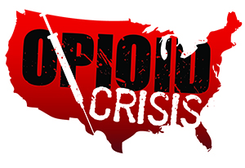](https://www.google.com/url?sa=i&rct=j&q=&esrc=s&source=images&cd=&ved=2ahUKEwiHjubz2PXfAhUORK0KHSOGA3gQjRx6BAgBEAU&url=https://www.getsmartaboutdrugs.gov/news-statistics/2018/06/12/preventing-youth-opioid-abuse&psig=AOvVaw2TwhHkeyTWSI4Pz1OisrHv&ust=1547844669112816)

Meramec Rural Opioid Program

Consortium Meeting

October 3, 2019

Meramec Regional Planning Commission, 4 Industrial Drive, St. James, MO

10:00 a.m.

1. **Call to Order and Introductions:** MRPC Staff, Samantha Maddison
2. **Staff Report:** MRPC staff will report on grant updates.
   1. PIMS Reporting – **Due to Samantha October 18, 2019**
      1. Samantha will explain what is required from each consortium member to complete the PIMS reporting – everyone should have received an email with the electronic form
   2. Workshop
      1. Mark will give an update on the status of the workshop
3. **Program Updates:** Members will update the group on their current efforts for the consortium and the progress they have made. Members will also have the opportunity to discuss any upcoming events or opioid related programs they are working on.
4. **Next Meetings:**
   1. Consortium will schedule meetings for January
      1. Tuesday January 7, 2020