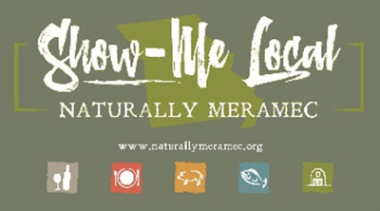

Naturally Meramec Consortium

Regional Meeting

September 26, 2019

Meramec Regional Planning Commission, 4 Industrial Drive, St. James, MO

6:00 p.m.

1. **Call to Order and Introductions:** Chair Deb Kleinheider.
2. **Approval of Minutes from the August 29, 2019 meeting:** Chair Deb Kleinheider.
3. **Staff Report:** Meramec Regional Planning Commission (MRPC) Staff will report on the Naturally Meramec Consortium (NMC) activities.
4. **Food Hub Feasibility Study SWOC Analysis:** The Food Hub Feasibility Study is due at the end of the 2019 calendar year. The MRPC Staff and the NMC will review the previous SWOC (Strengths, Weaknesses, Opportunities, and Challenges) analysis for the Meramec Region that was completed at the August 29, 2019 Naturally Meramec Consortium Regional Meeting. The SWOC analysis was prioritized using the dot method with the most dots being from top to bottom.
5. **Distribution of Products:**
   1. St. James Winery
6. **Announcements:** Members will have an opportunity to announce special events in their areas.
7. **Next Meeting:** Thursday, October 31, 2019 at 6:00 p.m. The MRPC Staff will discuss additional chapters and analysis related to the Food Hub Feasibility Study.
8. **Networking:** Members will have an opportunity to network.
9. **Adjournment**