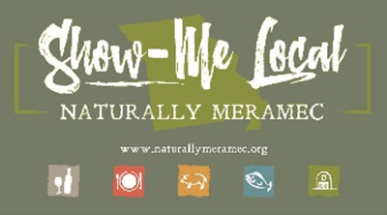

Naturally Meramec Consortium

Regional Meeting

August 29, 2019

Meramec Regional Planning Commission, 4 Industrial Drive, St. James, MO

6:00 p.m.

1. **Call to Order and Introductions:** Chair Deb Kleinheider.
2. **Approval of Minutes from the July 25, 2019 meeting:** Chair Deb Kleinheider.
3. **Staff Report:** MRPC staff will report on NMC activities.
4. **Food Hub Feasibility Study SWOC Analysis:** The Food Hub Feasibility Study is due at the end of the 2019 calendar year. The MRPC Staff and the Naturally Meramec Consortium will review the previous SWOC (Strengths, Weaknesses, Opportunities, and Challenges) analysis for the Meramec Region that was completed at the July 25, 2019 Naturally Meramec Consortium Regional Meeting and add any items not currently discussed. The MRPC Staff and the Naturally Meramec Consortium will prioritize using the dot method.
   1. **Strengths:** What are the strengths of each food value chain in the Meramec Region?
   2. **Weaknesses:** What is holding back each food value chain and what issues are impacting growth in the Meramec Region?
   3. **Opportunities:** What are opportunities for growth in the Meramec Region and how do we capture them?
   4. **Challenges:** What issues or forces could negatively impact future growth or success in the Meramec Region?
5. **Announcements:** Members will have an opportunity to announce special events in their areas.
6. **Next Meeting:** Thursday, September 26, 2019 at 6:00 p.m. The MRPC Staff will discuss additional chapters and analysis related to the Food Hub Feasibility Study.
7. **Networking:** Members will have an opportunity to network.
8. **Adjournment**