[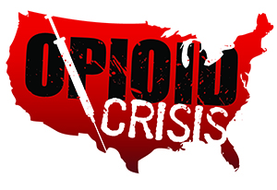](https://www.google.com/url?sa=i&rct=j&q=&esrc=s&source=images&cd=&ved=2ahUKEwiHjubz2PXfAhUORK0KHSOGA3gQjRx6BAgBEAU&url=https://www.getsmartaboutdrugs.gov/news-statistics/2018/06/12/preventing-youth-opioid-abuse&psig=AOvVaw2TwhHkeyTWSI4Pz1OisrHv&ust=1547844669112816)

Meramec Rural Opioid Program

Consortium Meeting

July 16, 2019

Meramec Regional Planning Commission, 4 Industrial Drive, St. James, MO

1:00 p.m.

1. **Call to Order and Introductions:** MRPC Staff, Samantha Maddison
2. **New Staff Introduction:** Anne Freand, Planning Department Manager
3. **Staff Report:** MRPC staff will report on grant updates.
   1. Resource List for each county
   2. Progress Report
   3. PIMS Reporting
      1. Samantha will explain what is required from each consortium member to complete the PIMS reporting
4. **Program Updates:** Members will update the group on their current efforts for the consortium and the progress they have made. Members will also have the opportunity to discuss any upcoming events or opioid related programs they are working on.
5. **Next Meetings:**
   1. Consortium will schedule meetings for October and January