[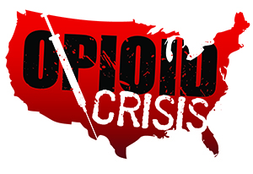](https://www.google.com/url?sa=i&rct=j&q=&esrc=s&source=images&cd=&ved=2ahUKEwiHjubz2PXfAhUORK0KHSOGA3gQjRx6BAgBEAU&url=https://www.getsmartaboutdrugs.gov/news-statistics/2018/06/12/preventing-youth-opioid-abuse&psig=AOvVaw2TwhHkeyTWSI4Pz1OisrHv&ust=1547844669112816)

Meramec Rural Opioid Program

Consortium Meeting

April 25, 2019

Meramec Regional Planning Commission, 4 Industrial Drive, St. James, MO

9:00 a.m.

1. **Call to Order and Introductions:** MRPC Staff, Samantha Maddison
2. **New Staff Introduction:** Mark Perkins
3. **Staff Report:** MRPC staff will report on grant updates.
   1. Morbidity and Mortality Review Update
   2. Survey Updates
4. **Grant Opportunity:** Opioid Affected Youth Initiative Grant Opportunity
   1. Consortium will be presented with goals and objectives of the grant application to discuss needs and current practices
5. **Annual Conference:** The group will decide who will attend the annual conference in Washington DC June 18-20 with Samantha.
   1. Leave afternoon of the 17th and return night of 20th
6. **Program Updates:** Members will update the group on their current efforts for the consortium and the progress they have made. Members will also have the opportunity to discuss any upcoming events or opioid related programs they are working on.