[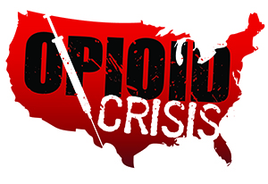](https://www.google.com/url?sa=i&rct=j&q=&esrc=s&source=images&cd=&ved=2ahUKEwiHjubz2PXfAhUORK0KHSOGA3gQjRx6BAgBEAU&url=https://www.getsmartaboutdrugs.gov/news-statistics/2018/06/12/preventing-youth-opioid-abuse&psig=AOvVaw2TwhHkeyTWSI4Pz1OisrHv&ust=1547844669112816)

Meramec Rural Opioid Program

Consortium Meeting

January 25, 2019

Meramec Regional Planning Commission, 4 Industrial Drive, St. James, MO

10:00 a.m.

1. **Call to Order and Introductions:** MRPC Staff, Samantha Maddison
2. **Staff Report:** MRPC staff will report on grant updates.
   1. Morbidity and Mortality Review Update
   2. Community Needs Assessment/ Naloxone Study Update
3. **Program Updates:** Members will update the group on their current efforts for the consortium and the progress they have made. Members will also have the opportunity to discuss any upcoming events or opioid related programs they are working on.