[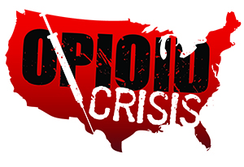](https://www.google.com/url?sa=i&rct=j&q=&esrc=s&source=images&cd=&ved=2ahUKEwiHjubz2PXfAhUORK0KHSOGA3gQjRx6BAgBEAU&url=https://www.getsmartaboutdrugs.gov/news-statistics/2018/06/12/preventing-youth-opioid-abuse&psig=AOvVaw2TwhHkeyTWSI4Pz1OisrHv&ust=1547844669112816)

Meramec Rural Opioid Program

Consortium Meeting

January 16, 2020

Meramec Regional Planning Commission, 4 Industrial Drive, St. James, MO

1:00 p.m.

1. **Call to Order and Introductions:** MRPC Staff, Samantha Maddison
2. **Staff Report:** MRPC staff will report on grant updates.
   1. Samantha will update the consortium on the new employees that will begin this month.
3. **Community Needs Assessment:** MRPC Staff, Samantha Maddison
   1. Consortium will discuss regional needs and discuss next steps for the years two and three of the current grant and potentially additional funding.
4. **OJJDP Grant:** MRPC Staff, Samantha Maddison
   1. Members will identify specific participants for the OJJDP Consortium of at least 12 members from the following sectors:
      1. Law enforcement, prosecutors, courts, probation, Division of Family Services, health care, mental health, and prevention organizations
   2. The group will discuss possible times and dates for the first OJJDP Consortium meeting. Staff would like to set a date in February 2020.
5. **Program Updates:** Members will update the group on their current efforts for the consortium and the progress they have made. Members will also have the opportunity to discuss any upcoming events or opioid related programs they are working on.
6. **Next Meetings:**
   1. Consortium will be sent a survey to schedule meeting for April