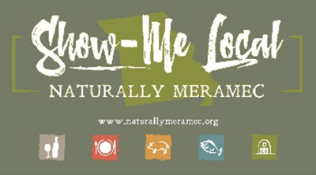

Naturally Meramec Consortium

Regional Meeting

January 30, 2020

Meramec Regional Planning Commission, 4 Industrial Drive, St. James, MO

6:00 p.m.

1. **Call to Order and Introductions:** Chair Deb Kleinheider.
2. **Approval of Minutes from the January 2, 2020 meeting:** Chair Deb Kleinheider.
3. **Staff Report:** Meramec Regional Planning Commission (MRPC) Staff will report on Naturally Meramec Consortium (NMC) activities through January 30, 2020.
4. **Presentation:** Hannah Riley, Search Marketing Specialist and April Barnett, Digital Media Strategist, Caledon Virtual.
   1. “Benefits of Consortium Social Media Engagement”.
5. **Announcements:** Members will have an opportunity to announce special events in their areas.
6. **Next Meeting:** Thursday, February 27, 2020 at 6:00 p.m.
7. **Networking:** Members will have an opportunity to network.
8. **Adjournment:** Chair Deb Kleinheider.