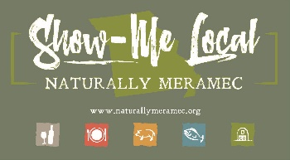

Naturally Meramec Consortium

Regional Meeting

January 2, 2020

Meramec Regional Planning Commission, 4 Industrial Drive, St. James, MO

6:00 p.m.

Meeting Minutes

**Call to Order:** Mark A. Perkins called the meeting to order at 6:10 p.m.

**Approval of Minutes from the December 5, 2019 meeting:** Mark A. Perkins presented the minutes for approval. John Gulick made a motion, seconded by Tim Smith, that the minutes be approved as presented. Motion passed.

**Staff Report:** Meramec Regional Planning Commission staff provided an update to Naturally Meramec Consortium attendees on the upcoming events for Naturally Meramec. Mark A. Perkins reported that the Naturally Meramec Consortium has grown to 80 members.

**MRPC Staff Presentation:** Mark A. Perkins presented a draft of the Missouri’s Meramec Region Food Hub Feasibility Study. There were discussions on the outcomes as well as the recommendations moving forward from the study. Topics included the Table of Contents which also included detailed discussions about the following chapters: History of the Region, General Land Use, Natural Resources, Food Deserts, and Definition of a Food Hub.

**Announcements:** The Naturally Meramec Consortium attendees were able to make any announcements about their business and discuss any upcoming events.

**Next Meeting:** The next Naturally Meramec Consortium Regional Meeting is scheduled for Thursday, January 30, 2020 at 6:00 p.m.

**Networking:** After the meeting, Naturally Meramec Consortium attendees were able to network with other attendees.

**Adjournment:** Tim Smith made a motion to adjourn, seconded by Tamra Cape. Motion passed.