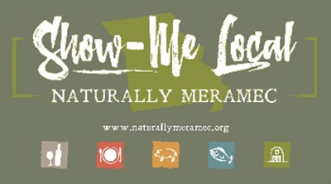

Naturally Meramec Consortium

Regional Meeting

January 2, 2020

Meramec Regional Planning Commission, 4 Industrial Drive, St. James, MO

6:00 p.m.

1. **Call to Order and Introductions:** Chair Deb Kleinheider.
2. **Approval of Minutes from the December 5, 2019 meeting:** Chair Deb Kleinheider.
3. **Staff Report:** Meramec Regional Planning Commission (MRPC) Staff will report on Naturally Meramec Consortium (NMC) activities through December 31, 2019.
4. **MRPC Staff Presentation:** Mark A. Perkins, Senior Community Development Specialist, MRPC
   1. Missouri’s Meramec Region Food Hub Feasibility Study (DRAFT)

* Continue discussion on the outcomes as well as the recommendations moving forward from the study.

1. **Announcements:** Members will have an opportunity to announce special events in their areas.
2. **Next Meeting:** Thursday, January 30, 2020 at 6:00 p.m.
3. **Networking:** Members will have an opportunity to network.
4. **Adjournment:** Chair Deb Kleinheider.