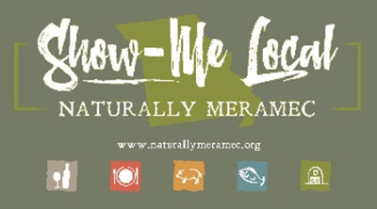

Naturally Meramec Consortium

Regional Meeting

June 27, 2019

Meramec Regional Planning Commission, 4 Industrial Drive, St. James, MO

6:00 p.m.

1. **Call to Order and Introductions:** Chair Deb Kleinheider.
2. **Approval of Minutes from the May 30, 2019 meeting:** Chair Deb Kleinheider.
3. **Missouri Science & Technology Introductions:**
4. **Staff Report:** MRPC staff will report on NMC activities.
   1. Food Hub Feasibility Study Update
5. **Presentation:** J. Michael Roach, Creative Director and Nell Roach, President, Caledon Virtual
   1. “Tips for a successful social media presence with a limited budget”.
6. **Announcements:** Members will have an opportunity to announce special events in their areas.
7. **Next Meeting:** Thursday, July 25, 2019 6:00 p.m.
8. **Networking:** Members will have an opportunity to network.
9. **Adjournment**