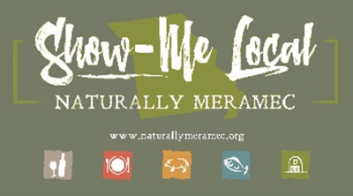

Naturally Meramec Consortium

Regional Meeting

January 24, 2019

Meramec Regional Planning Commission, 4 Industrial Drive, St. James, MO

6:00 p.m.

1. **Call to Order and Introductions:** Chair Deb Kleinheider.
2. **Approval of Minutes from the January 24, 2019 meeting:** Chair Deb Kleinheider.
3. **Nomination of new Vice Chair:** Deb Kleinheider
4. **Staff Report:** MRPC staff will report on NMC activities.
   1. Membership: Update group on membership and review new marketing materials
   2. Update on food-hub study
   3. Future trainings
5. **Marketing Impact:** Caitlin Jones will update the group on website and Facebook traffic.
6. **Strategic Plan:** Members will work on establishing goals and objectives for the NMC, based upon business needs.
7. **Announcements:** Members will have an opportunity to announce special events in their areas.
8. **Networking:** Members will have an opportunity to network.